**Team 11**

**Assignment 2**

Vaishali Lambe

Rijuta Wagh

Ankur Muley

**Part 1: Data wrangling and exploratory data analysis**

**Data Download and pre-processing (Accepted Loan Data):**

**Script Name: DataExtraction.ipynb/dataextraction1.py**

**Downloads data from**

<https://www.lendingclub.com/info/download-data.action>

Downloaded data from above url.

Created one data set from multiple .csv files as Accpted_LoanData.csv

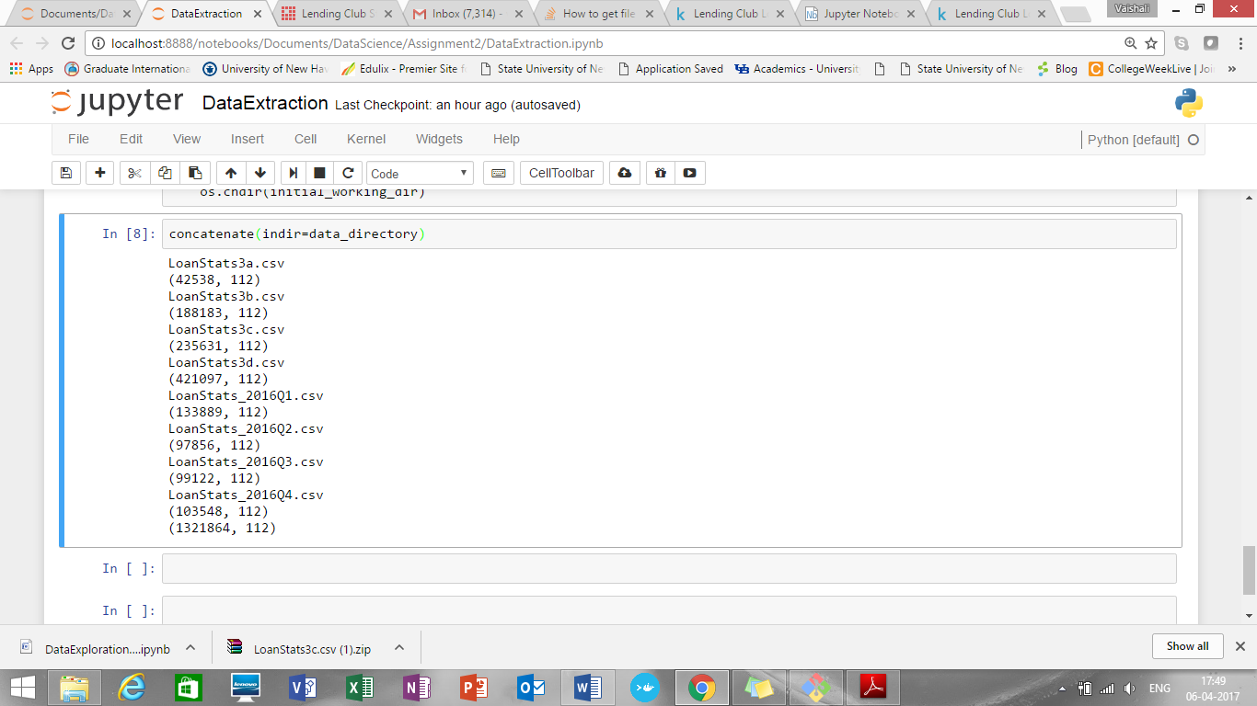

Added one more column timestamp to the data frame as below:

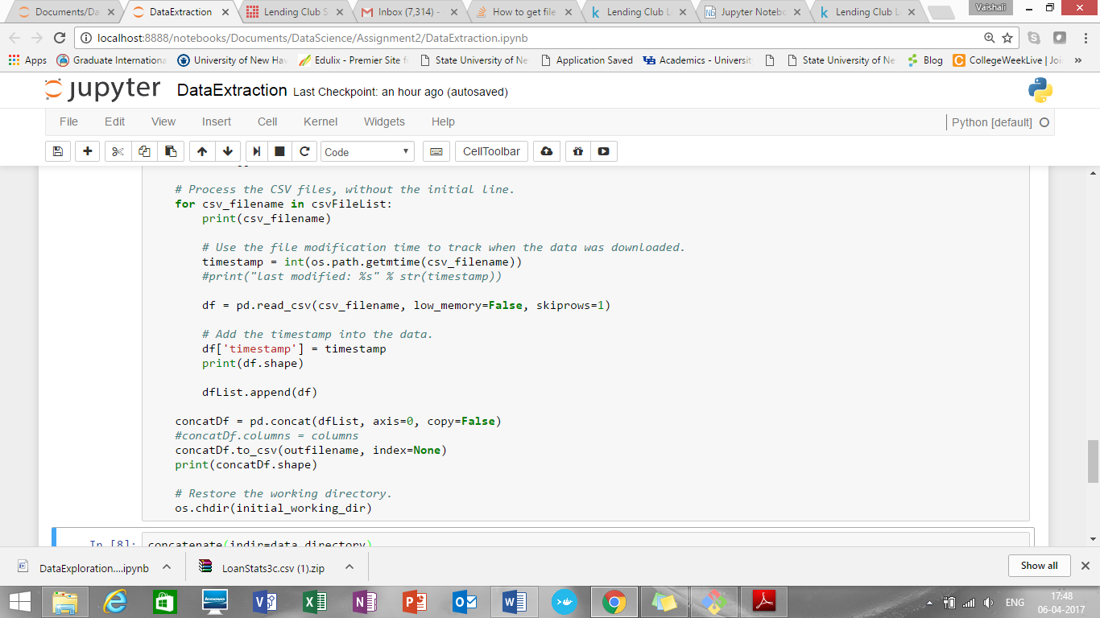

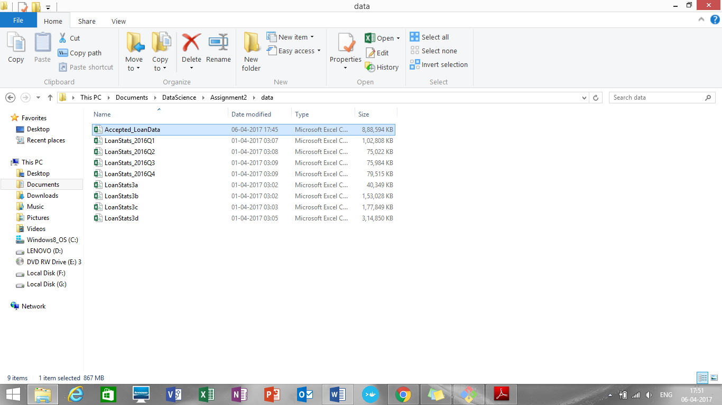

Also, we are providing check whether data files are already downloaded or not.

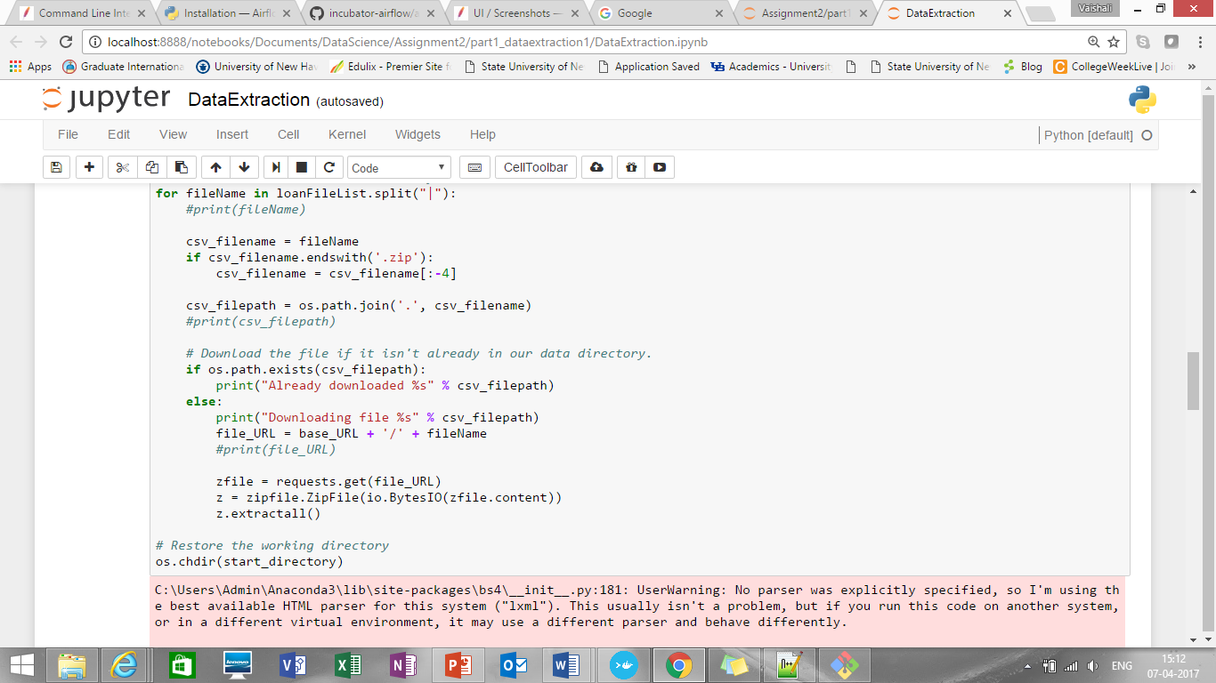

**Missing data handling:**

**Script Name: MissingDataHandling.ipynb/missingdatahandling1.py**

Checked data types of all column variables:

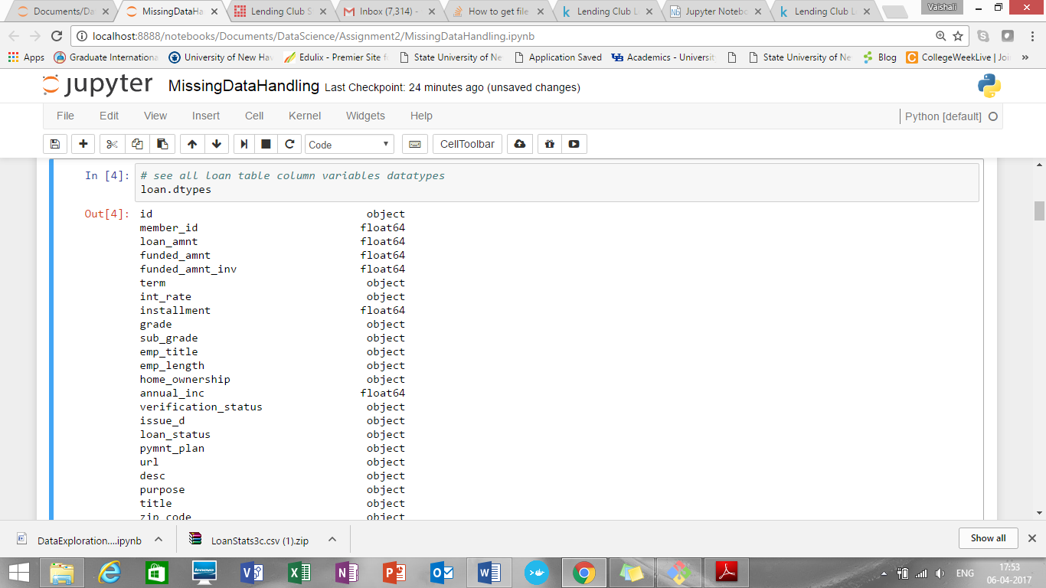

Find mean(), max(), min() of all column variables:

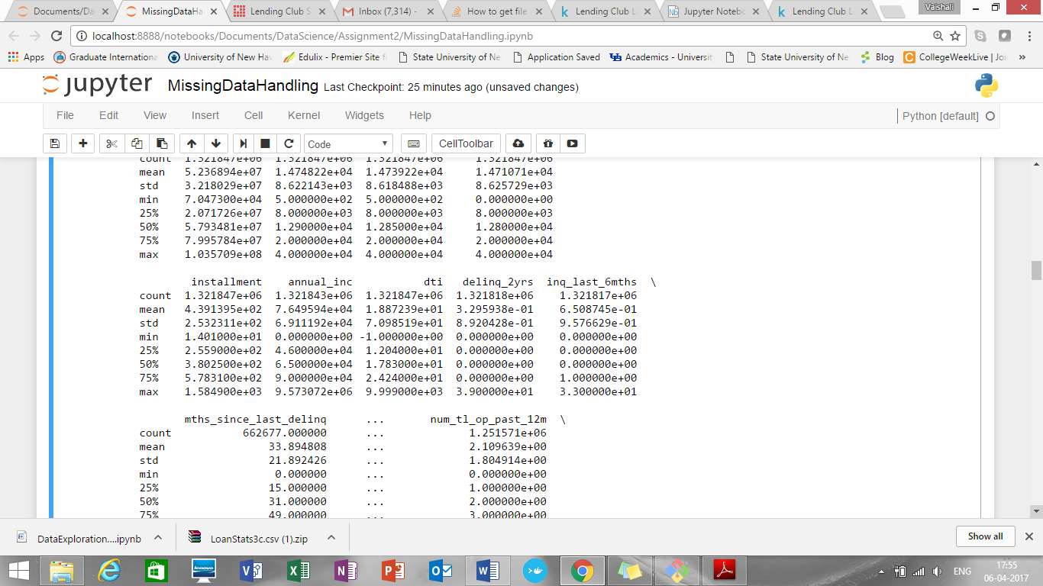

Cleaning and handling missing data:

1. ID and member ID have no predictive power. Do dropped
2. Employee titles aren't as useful as income or DTI ratio, so dropped
3. Payment plan is not needed, so dropped
4. The URL, description and title are non-numeric and not useful for predicting interest rates, so drop them, so dropped
5. Handled fico range and earliest credit as below:

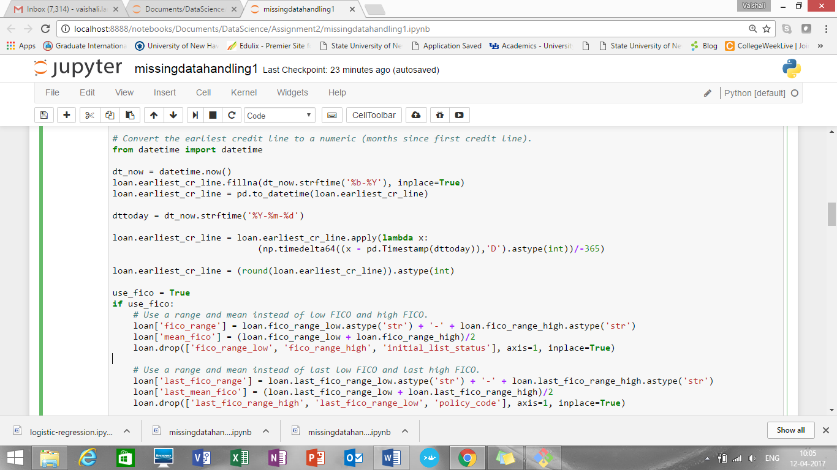

1. Dropped all below columns as have less significance :

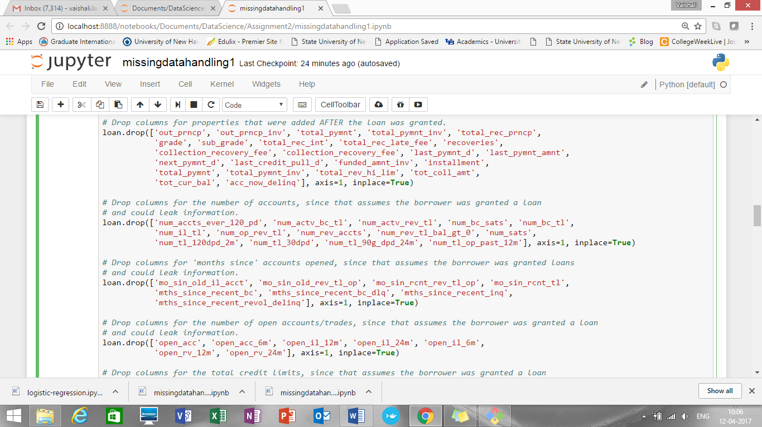

1. Handled employee length, verification joint status, interest rate, revol_util as below:

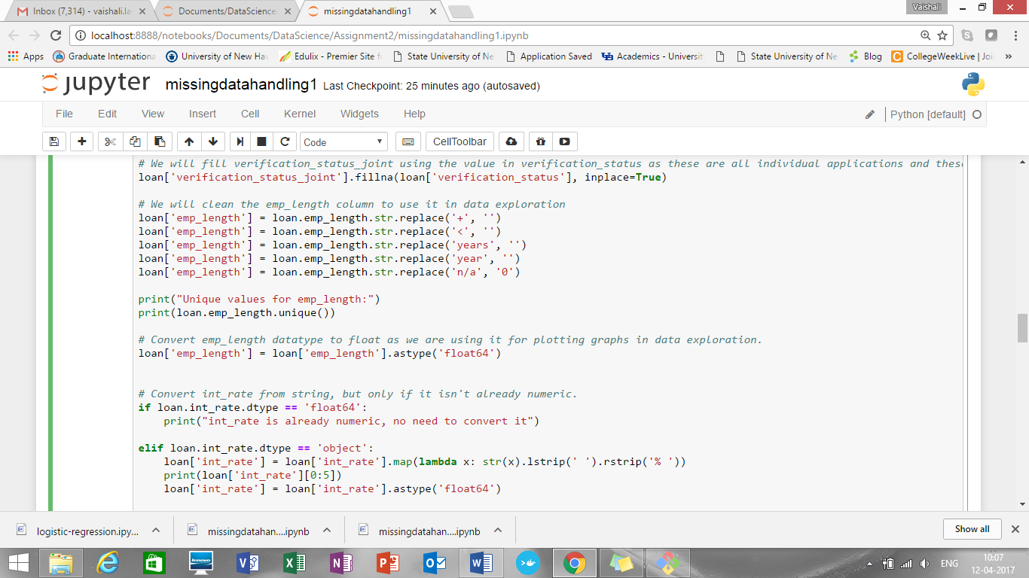

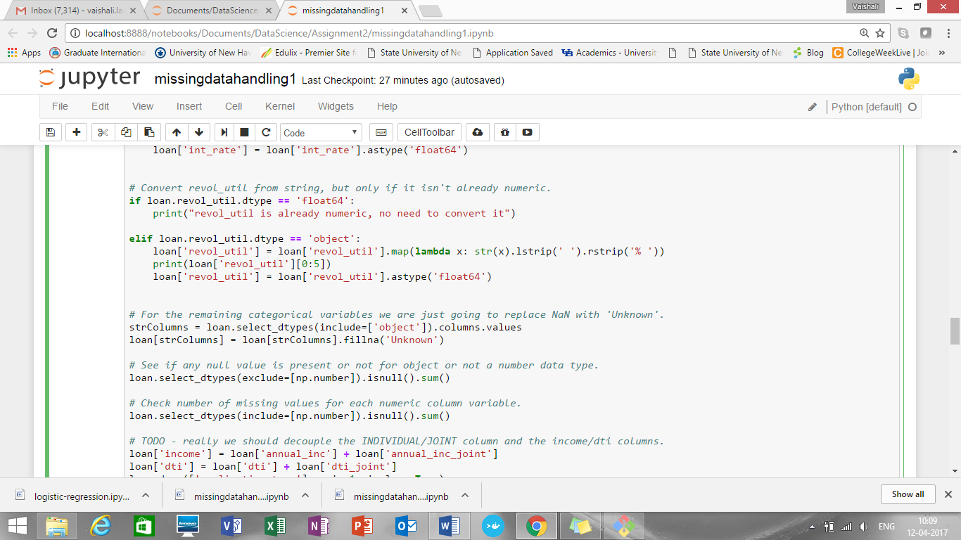

1. All remaining varibales are handled as below:

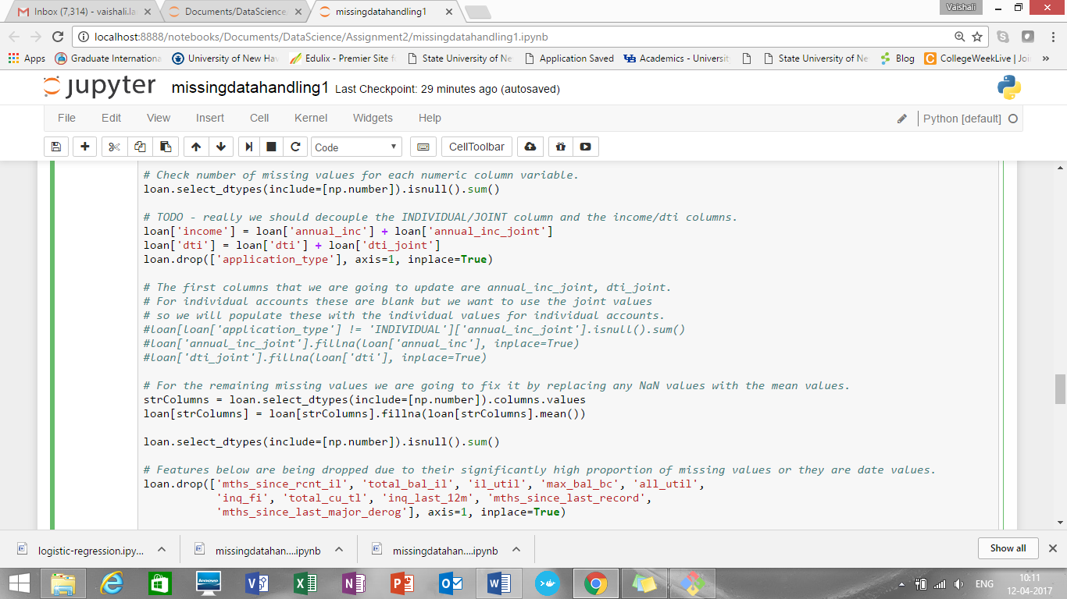

1. Checked coefficient of correlation for few columns and dropped columns which are co -related

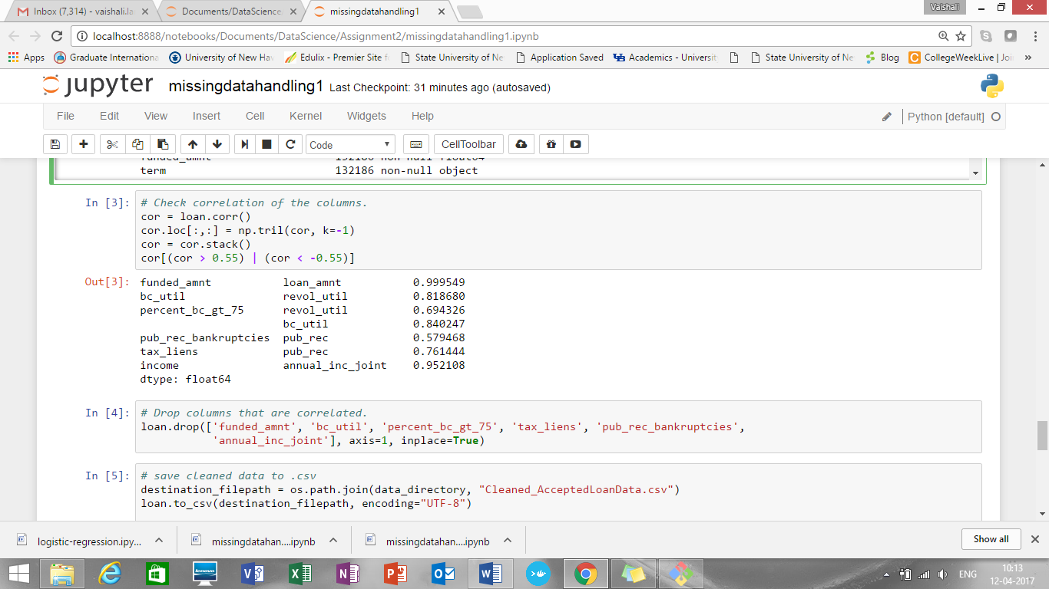

**Data Exploration using python:**

**Script Name: DataExploration.ipynb/dataexploartion1.py**

Annual_income and loan amount summary is:

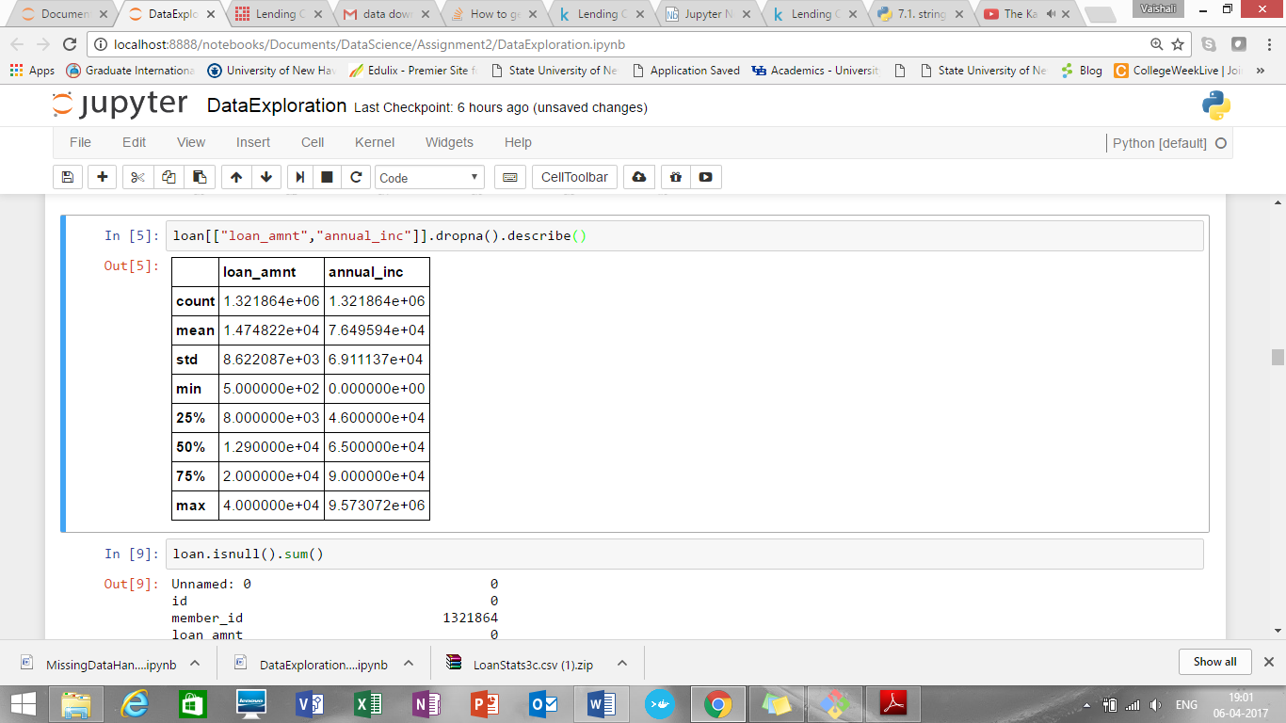

Distribution of int_rate:

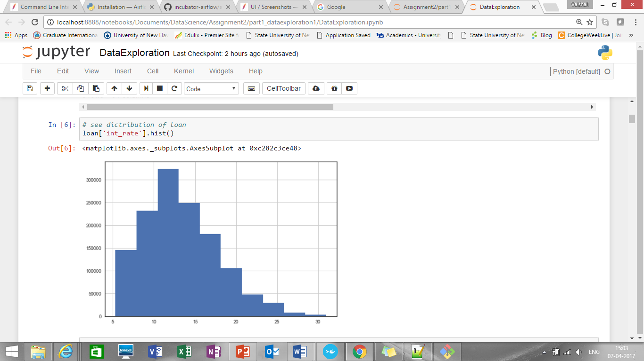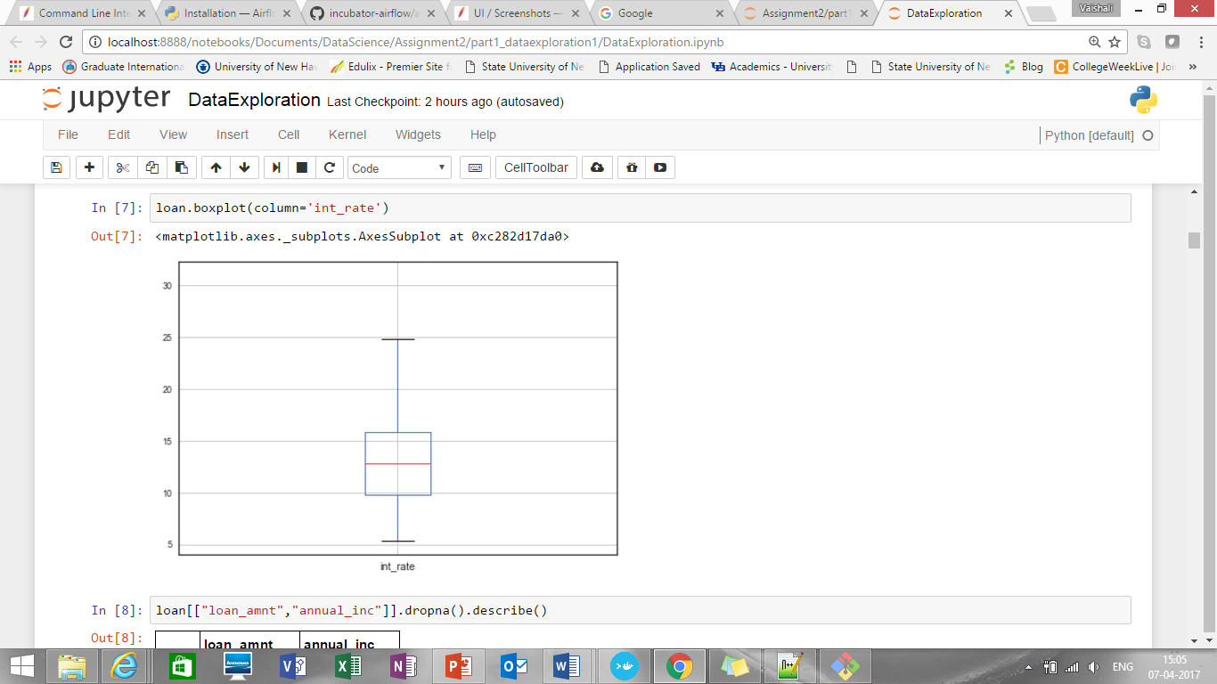

Median of interest rate is around 12 to 13%

1. Let’s see how loan amount affects interest rate:

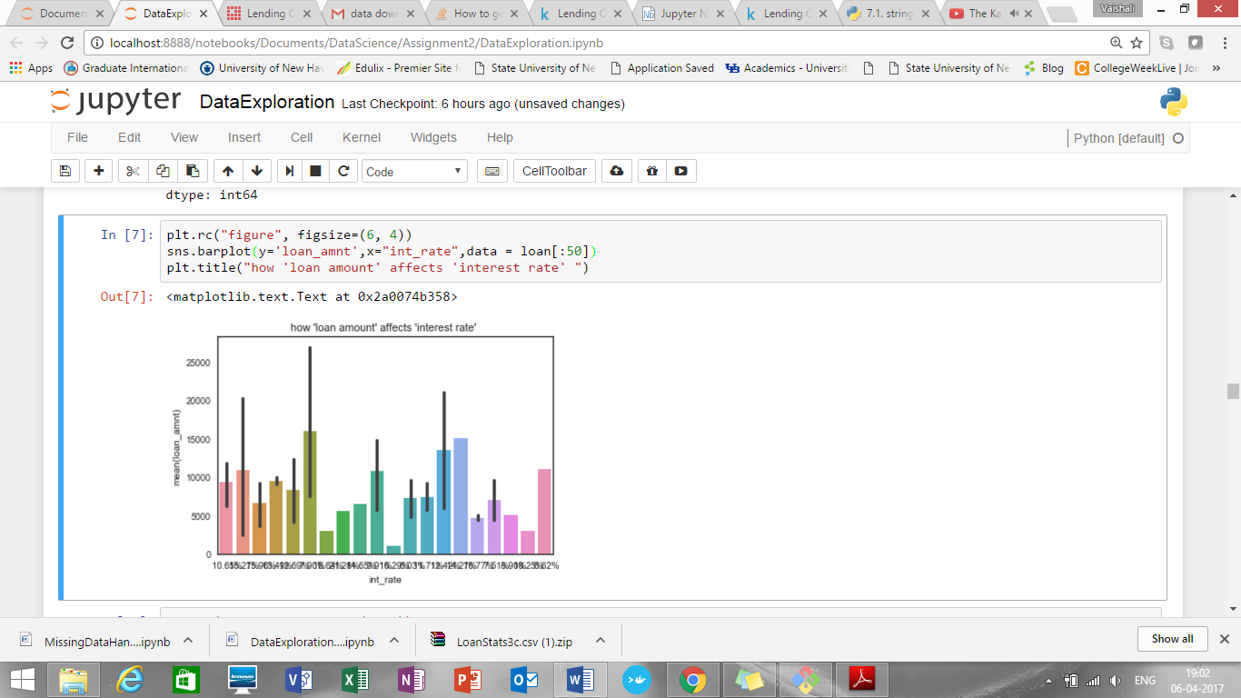

It shows that, lower the loan amount, higher the interest rate

1. Let’s see how annual income affects interest rate:

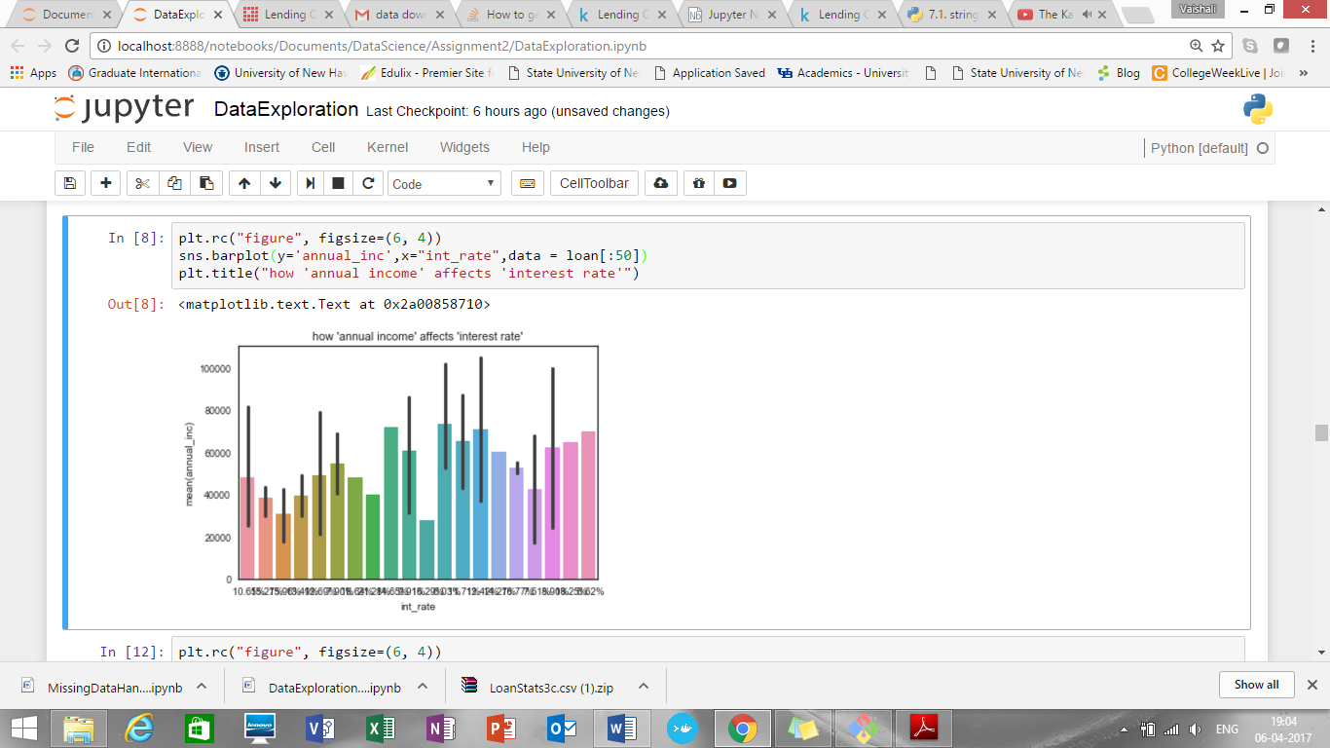

1. How term and interest rate are related

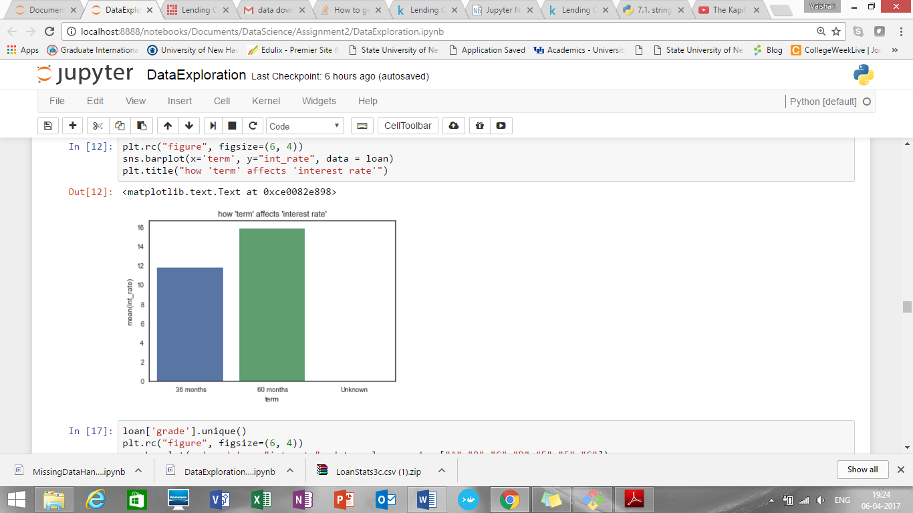

So, for higher term i.e. 60 months, interest rate is higher

1. How interest rate and grade are connected

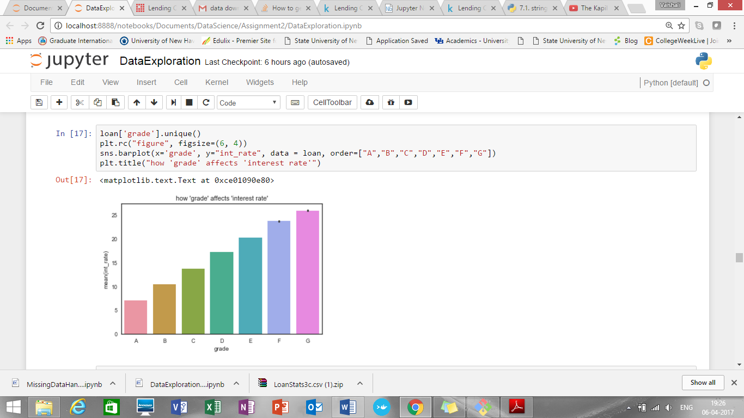

1. Let’s see how issue month or issue year affect the interest rate

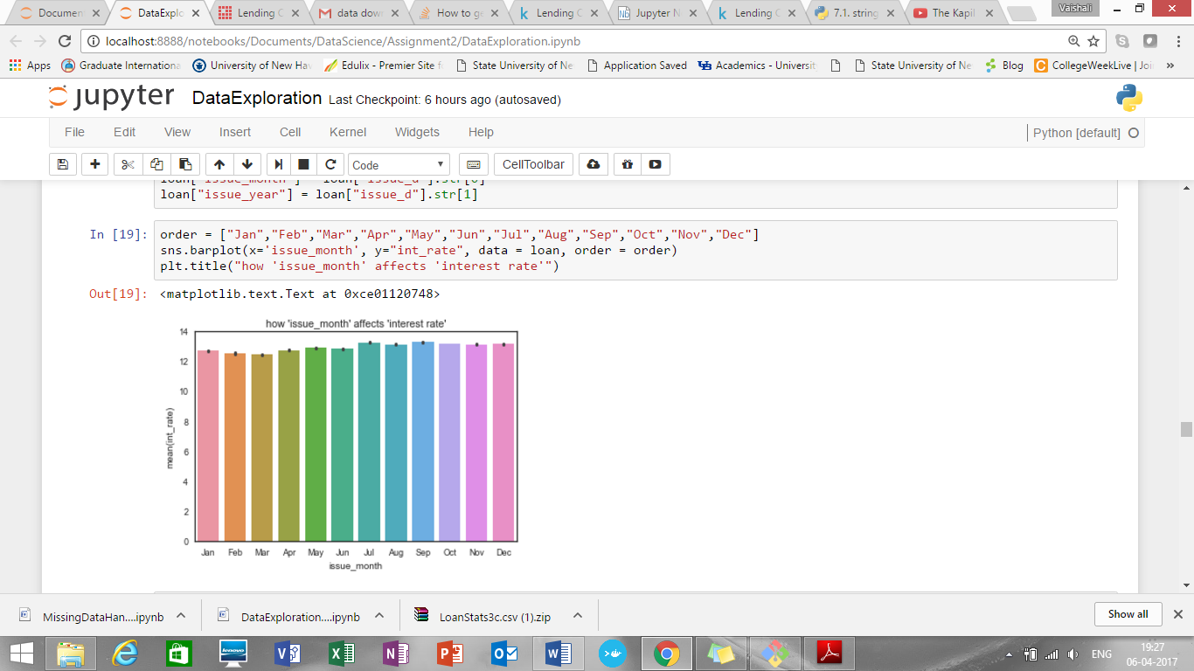

It shows that issue month has no such big impact on interest rate

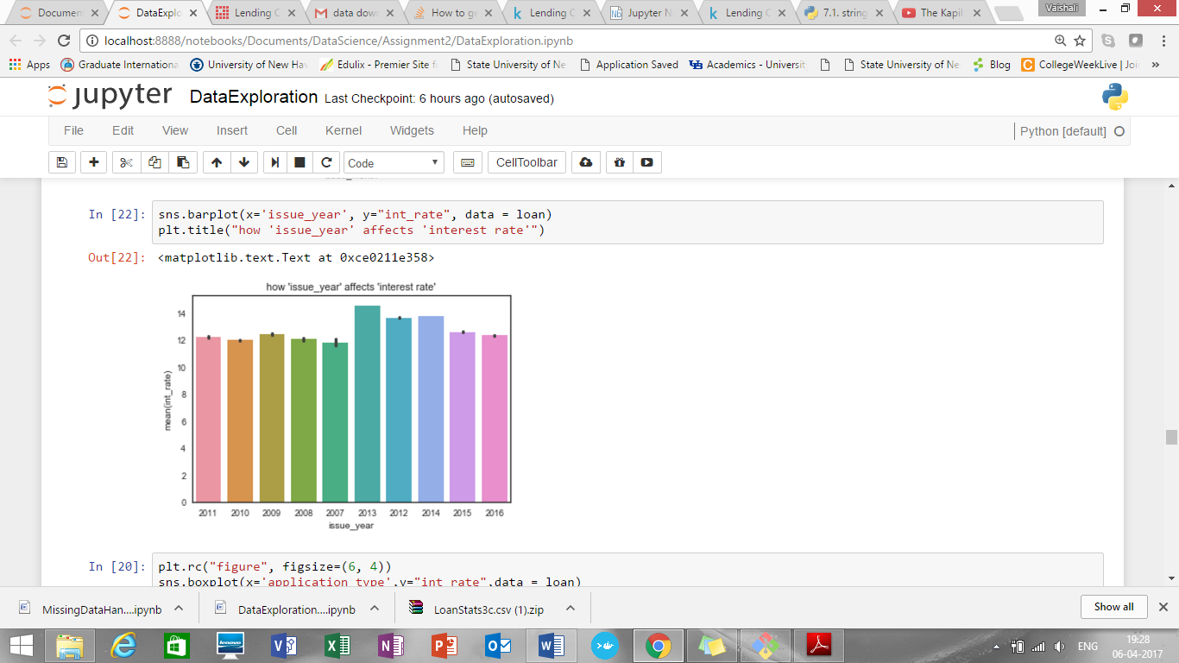

Also, issue year shows that, maximum interest was in 2013. Afterwards it again falls and in 2015 and 2016 there is little drop in interest rate

1. Application type Vs interest rate

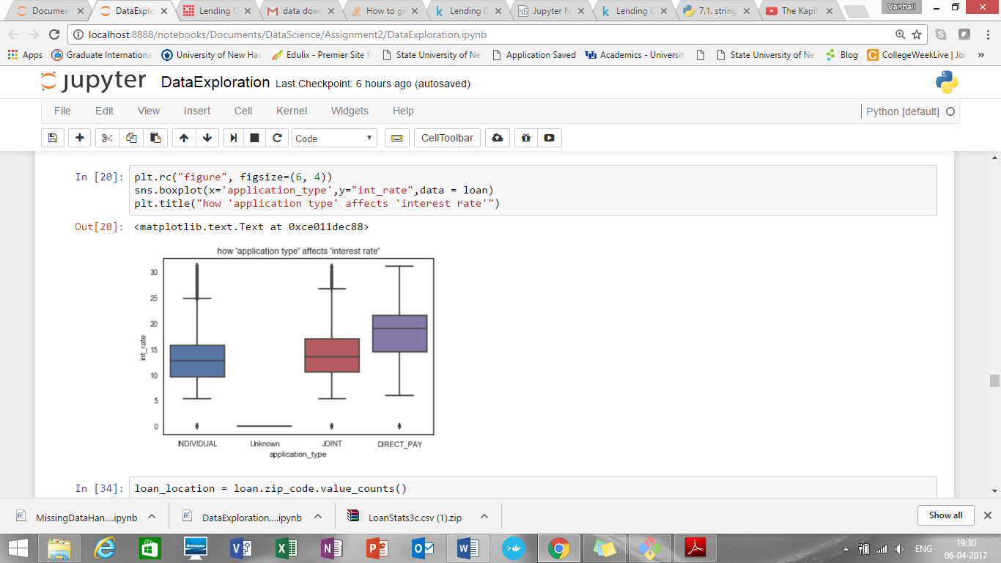

It shows that for “INDIVIDUAL” application type there is lowest interest rate compare to Joint and direct pay applications

1. Maximum borrowers are in CA
2. Loan status count for Current is maximum

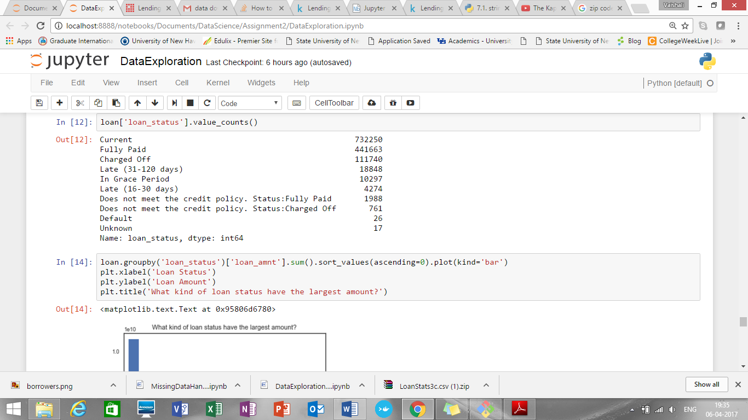

1. So, maximum loan amount is in Current loan status

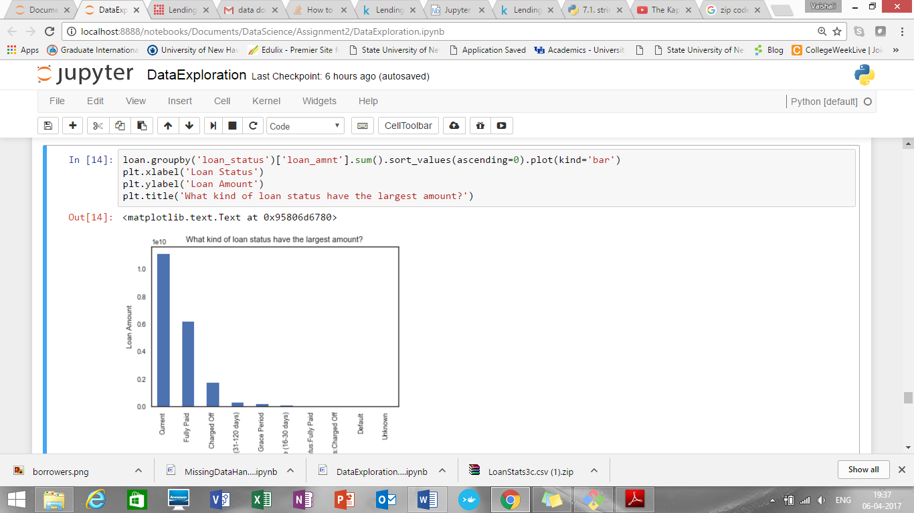

1. Maximum borrowers are found for loan for purpose “Debt consolidation”

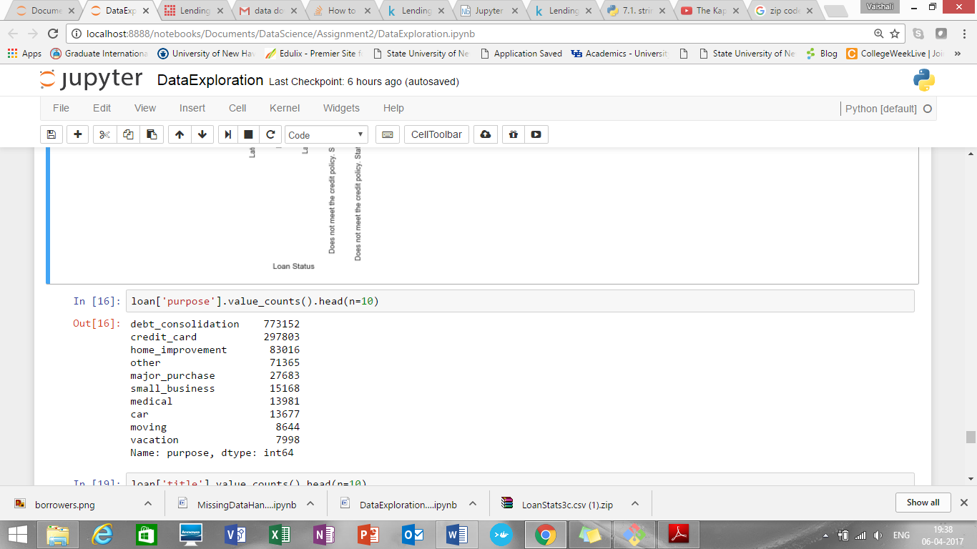

1. Volume of loan is maximum for Grade “B”

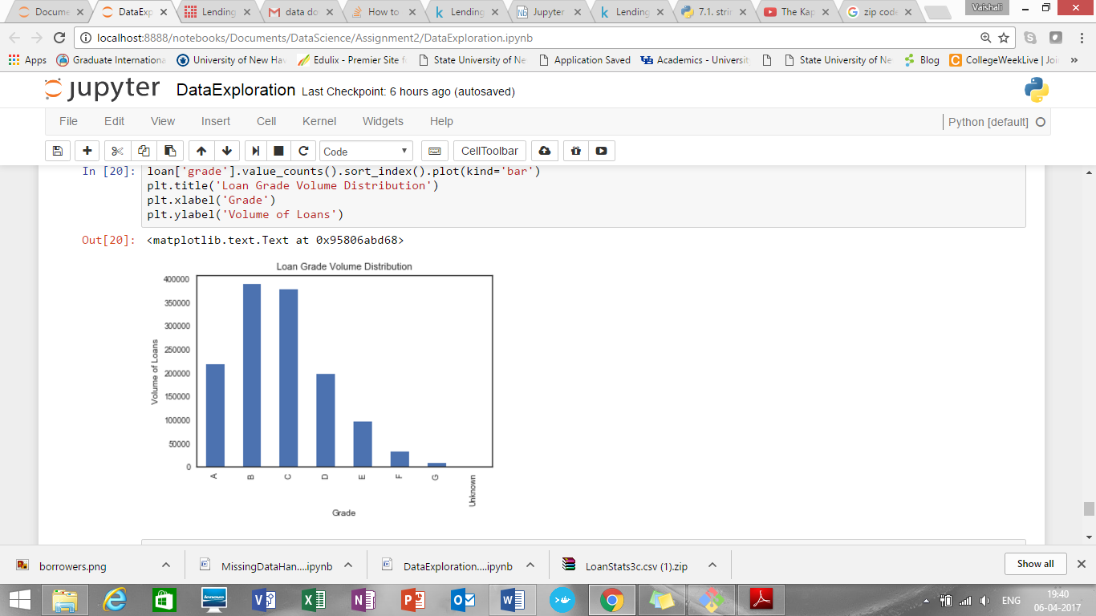

1. Amount of loan is maximum for grade” C”

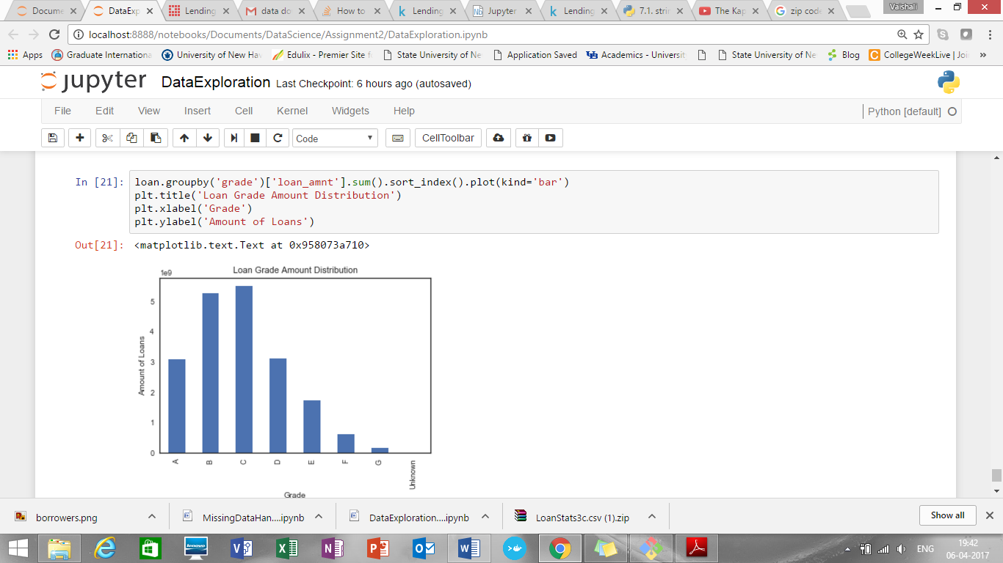

1. Number of loans Vs annual income

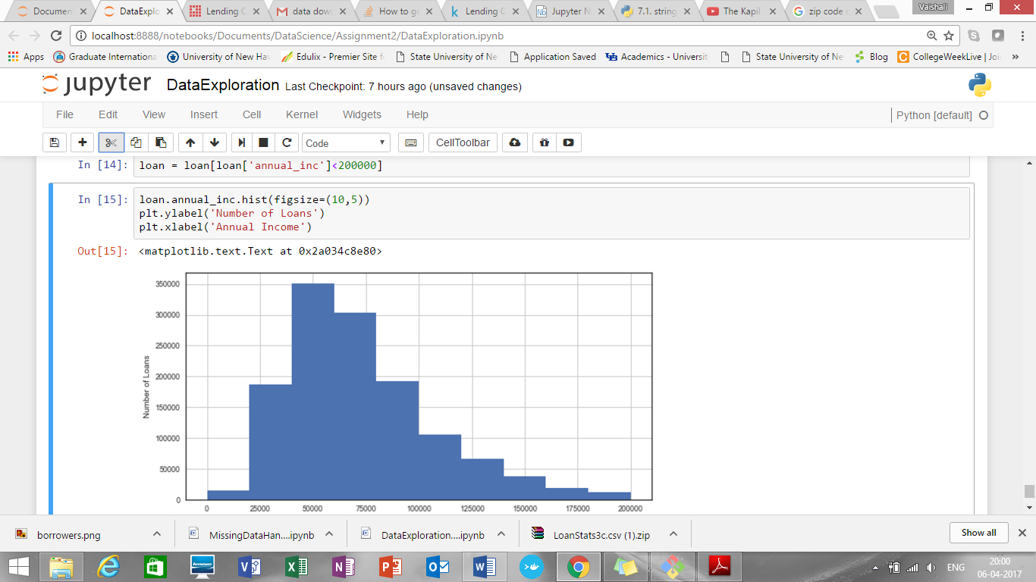

From above exploration, we can see that loan amount, annual income, term, state, purpose, loan status, grade has impact on interest rate. SO these variables will be helpful to predict the interest rate .

Number of loans are maximum for annual income in range 4000-6000 approximately

1. Create “default” for loan status

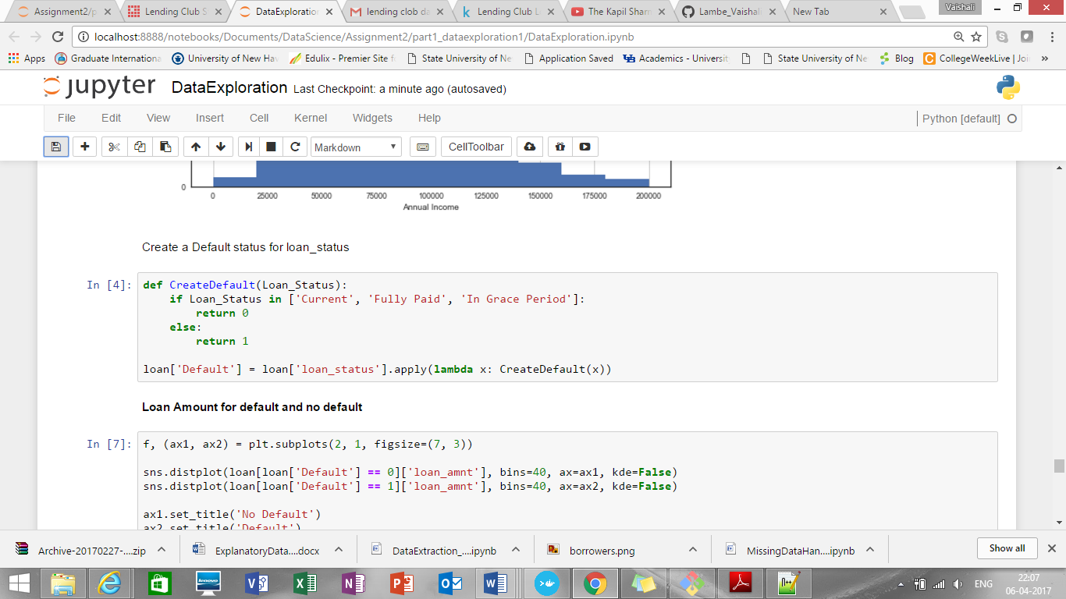

1. **Loan Amount for default and no default**

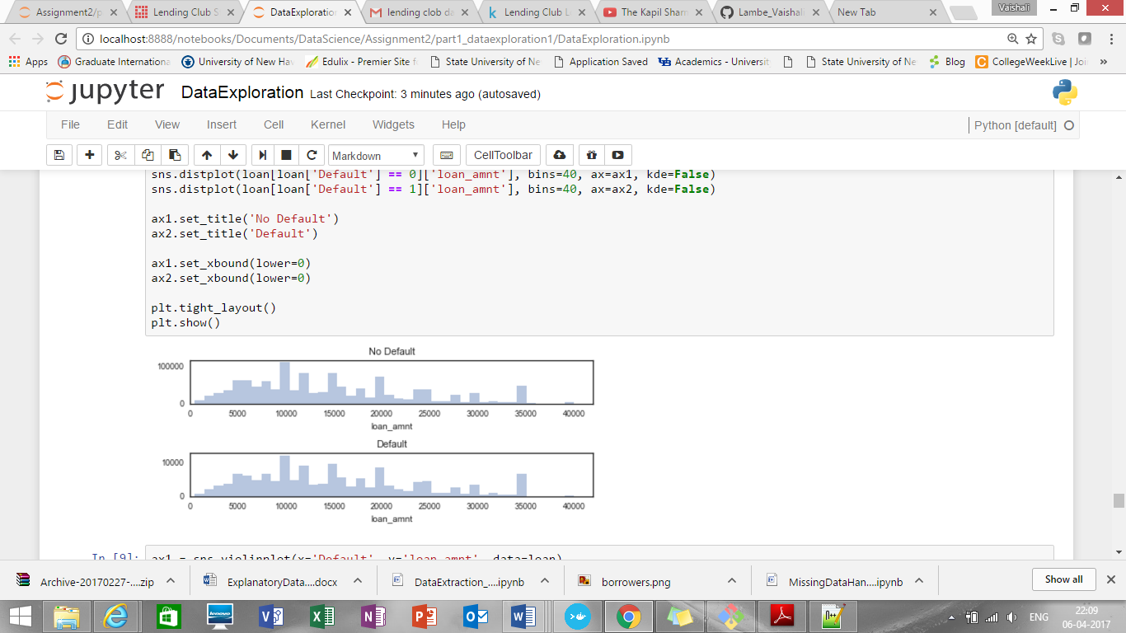

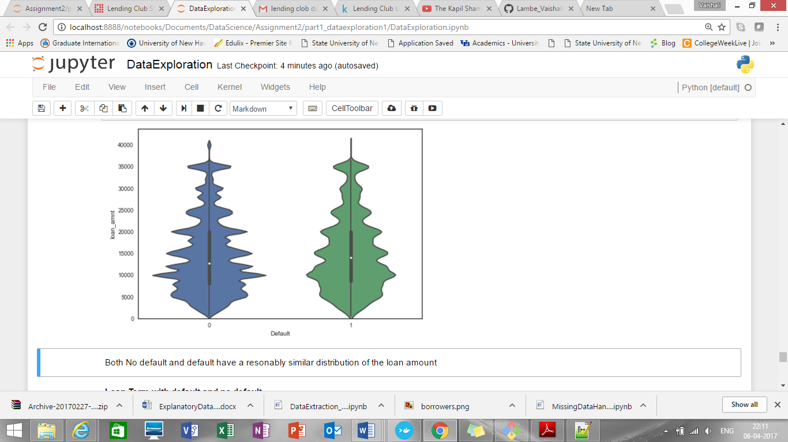

Both No default and default have a reasonably same distribution of the loan amount

1. **Loan Term with default and no default**

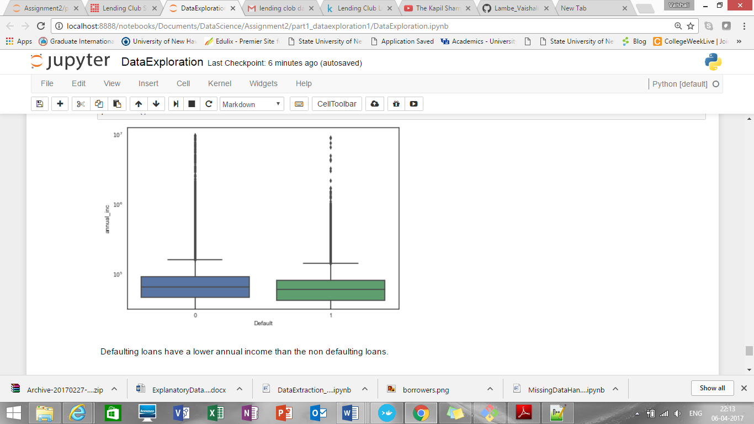

1. **Debt to income ratio for default and no default**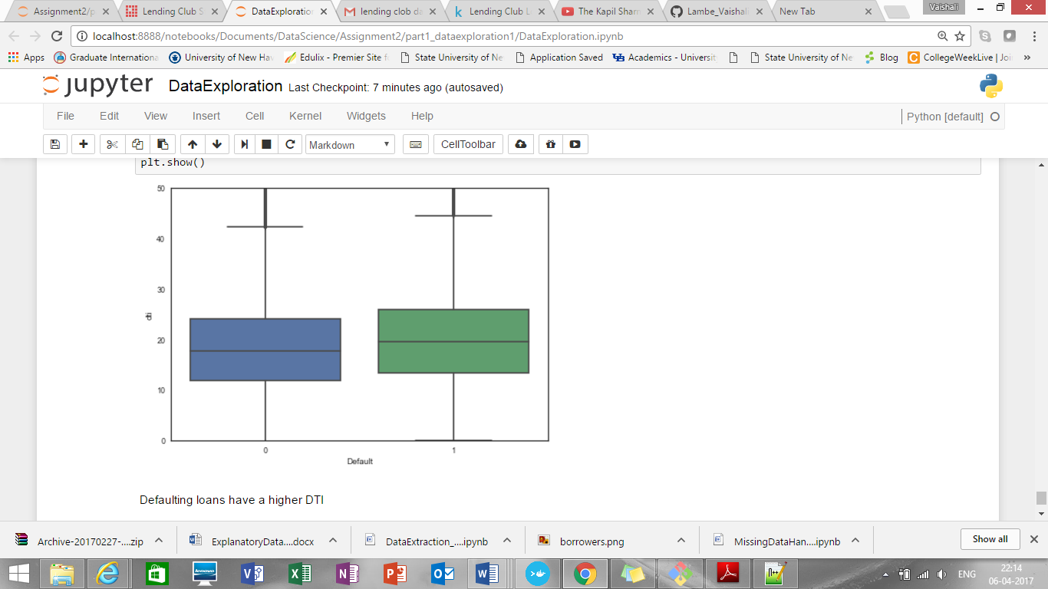

**Data Download and pre-processing (Declined Loan Data):**

**Script Name: DataExtraction.ipynb/DataExtraction_DeclinedLoanData.py**

**Downloads data from**

<https://www.lendingclub.com/info/download-data.action>

Downloaded data from url. Created one data set from multiple .csv files as Rejected_LoanData.csv

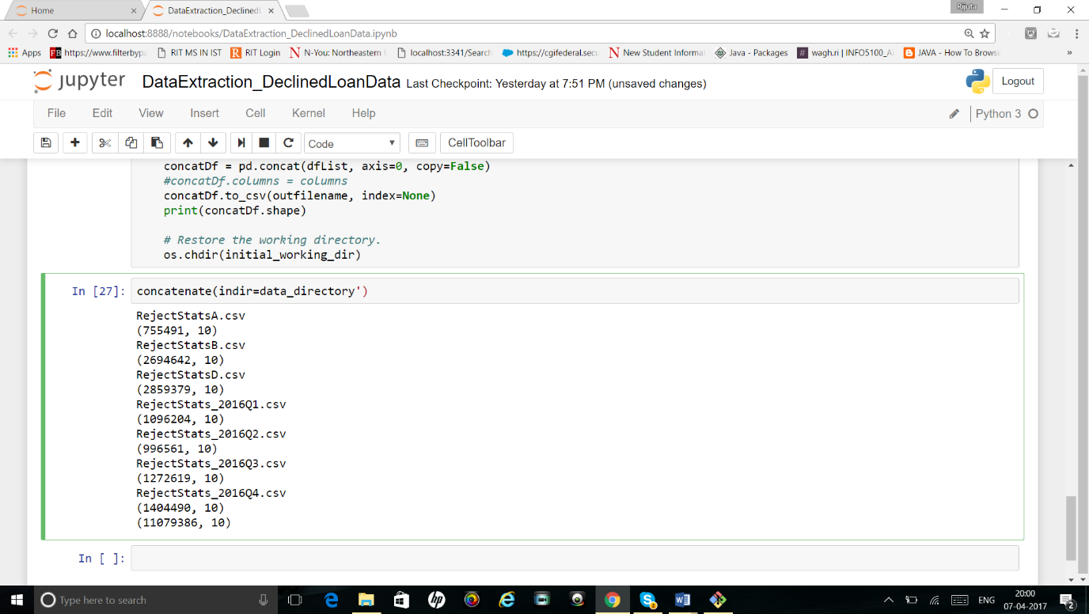

Added one more column timestamp as below:

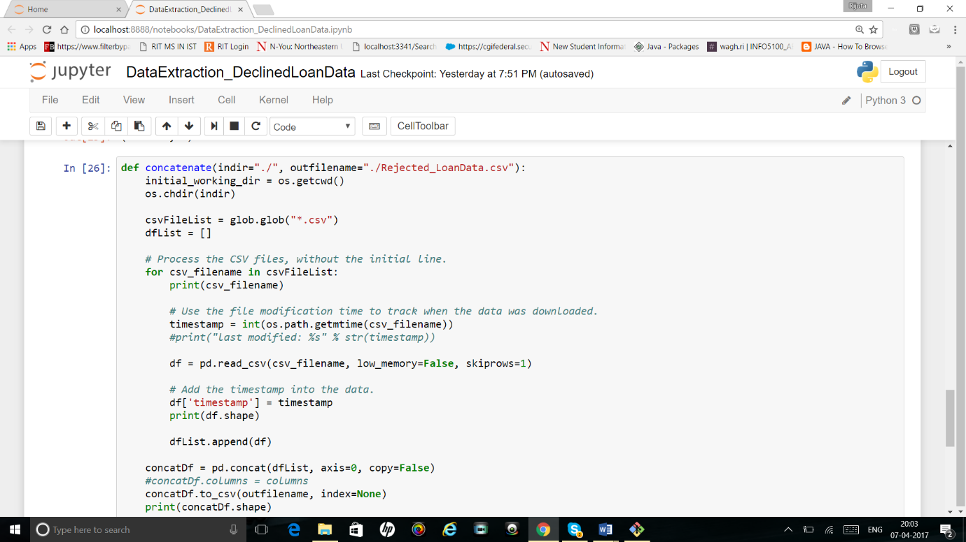

1. Also, we are providing check whether data files are already downloaded or not.

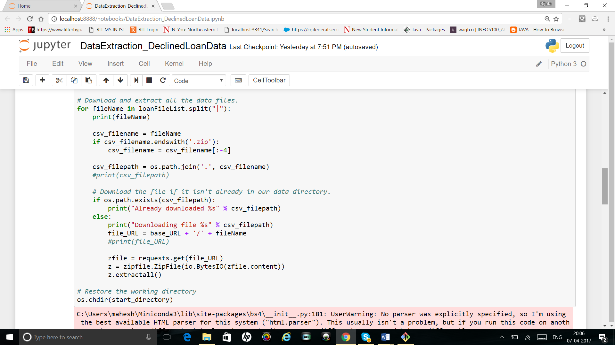

**Missing data handling:**

**Script Name for both Missing Data Handling and Exploratory Data Analysis: missingdatahandling-rejected.ipynb/**

**MissingDataHandling_DataExploration_DeclinedLoans.py**

Checked data types of all column variables:

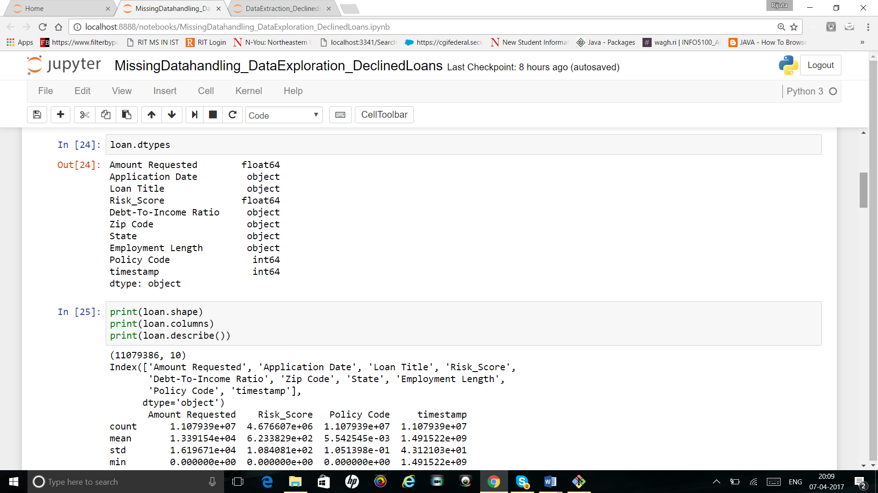

Find mean(), max(), min() of all column variables:

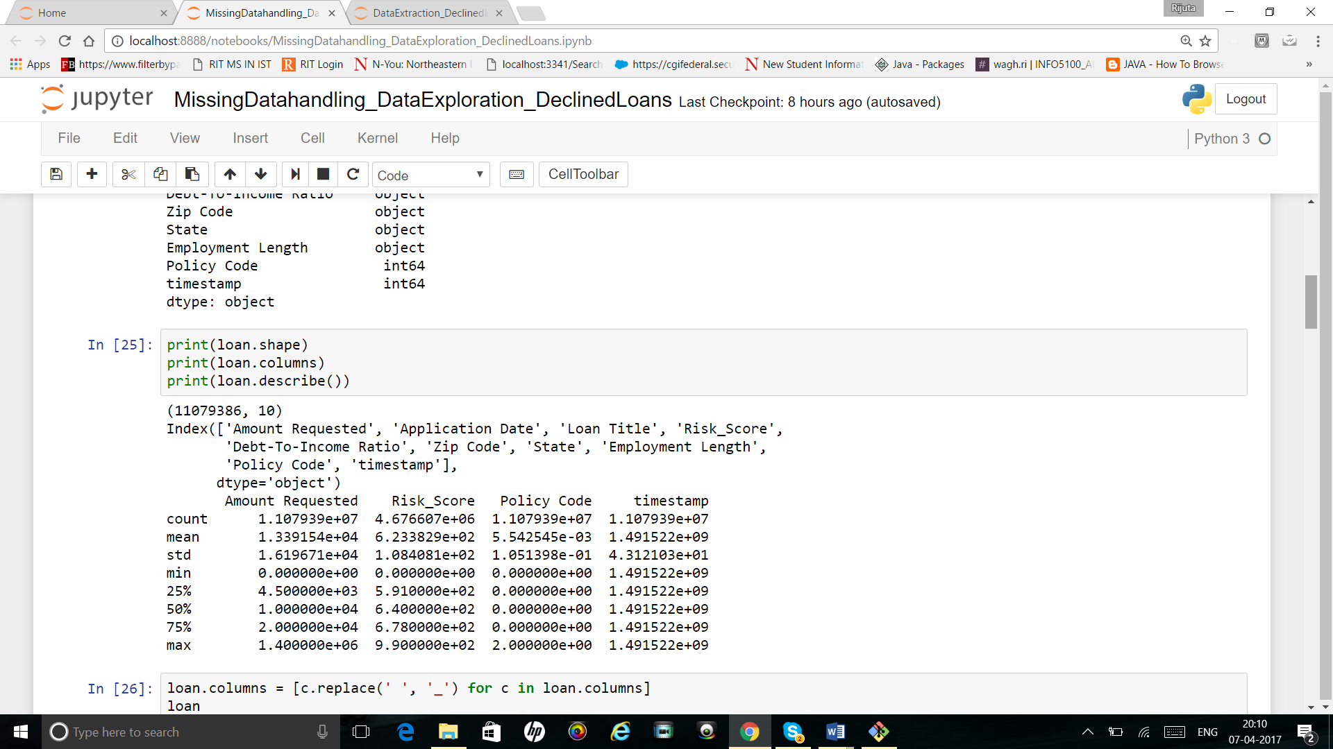

**Handling missing data:**

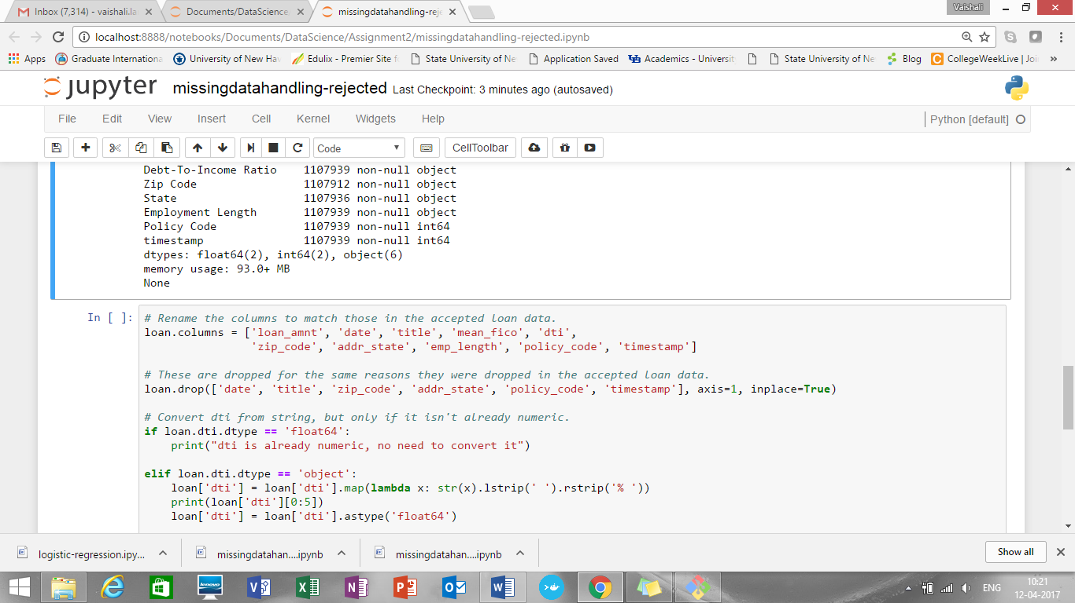

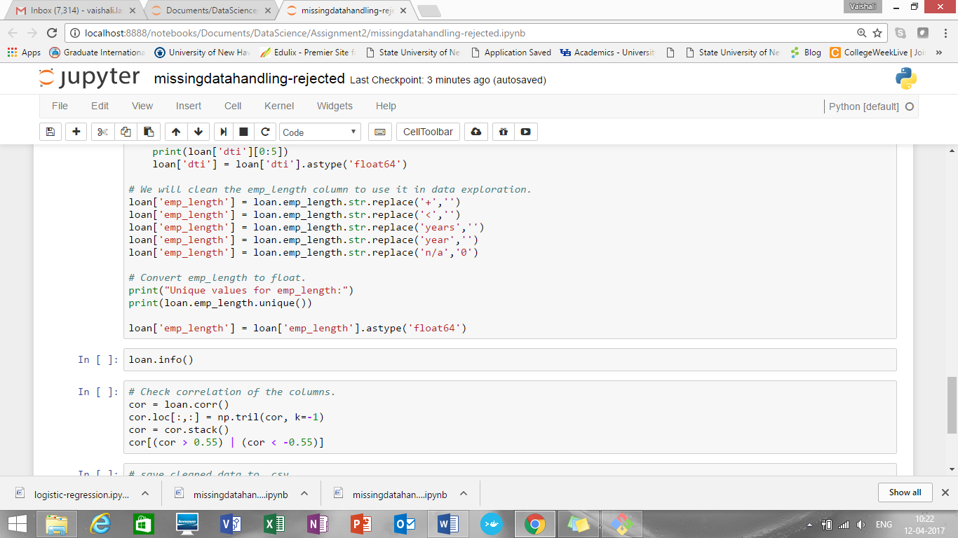

**Data Exploration using python:**

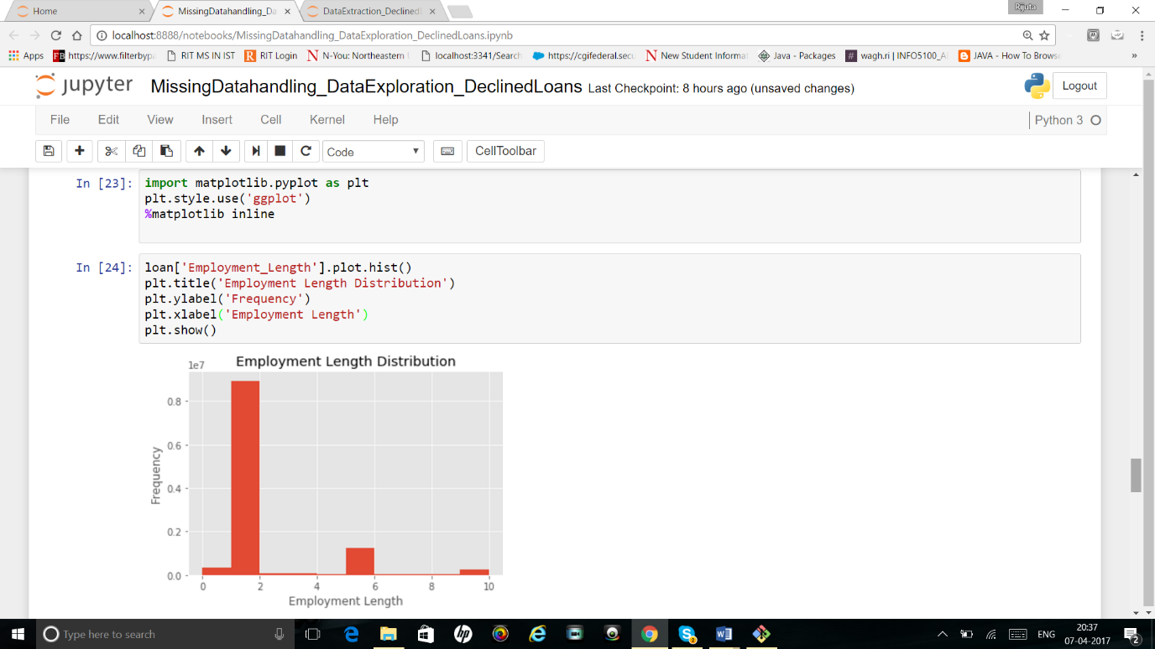

1. 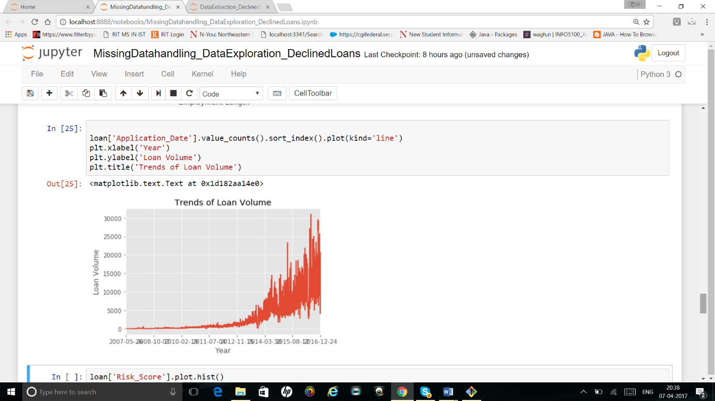

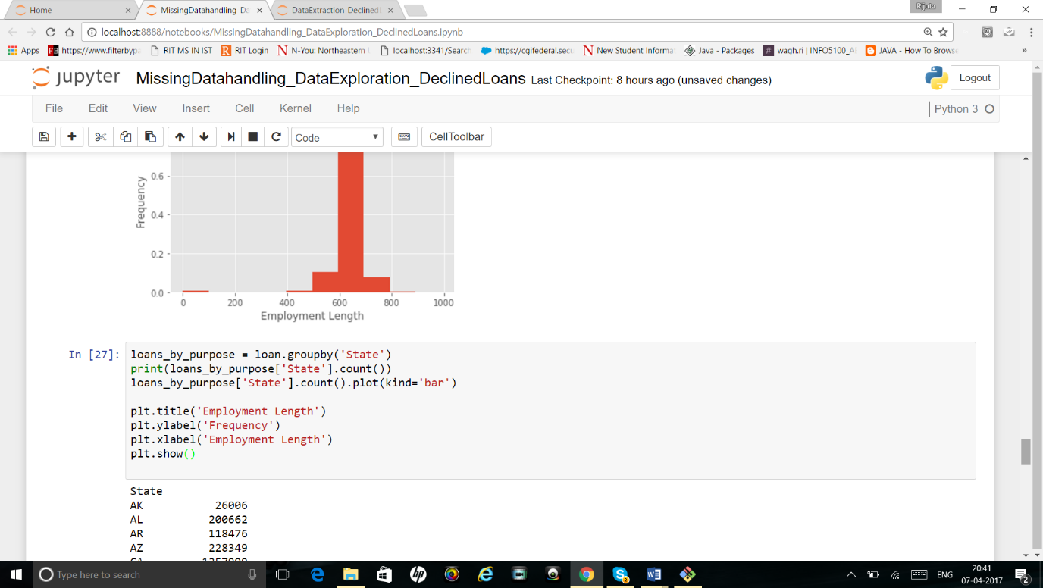

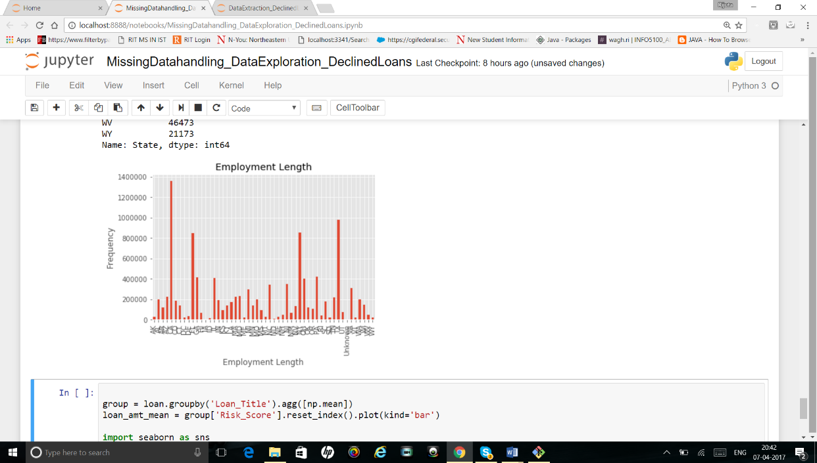

**PowerBI Analysis:**

Accepted Data Dashboard 1

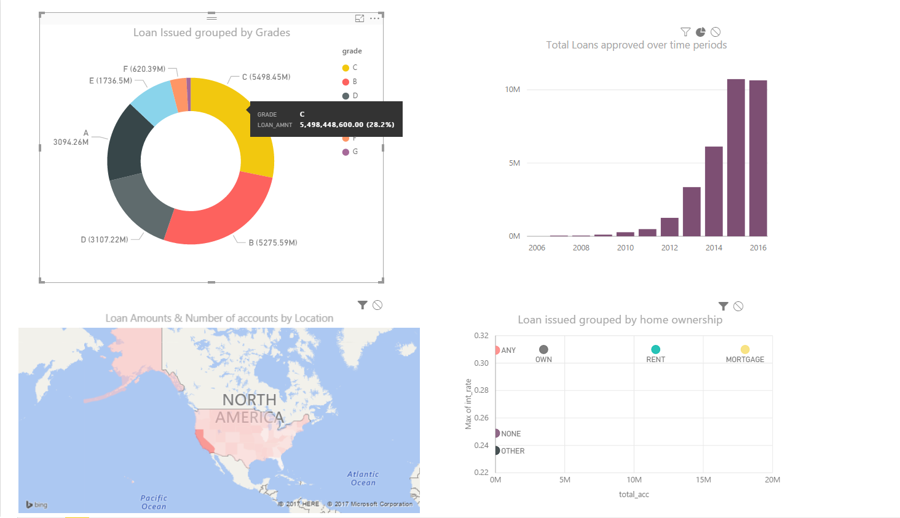

Accepted Data Dashboard 2

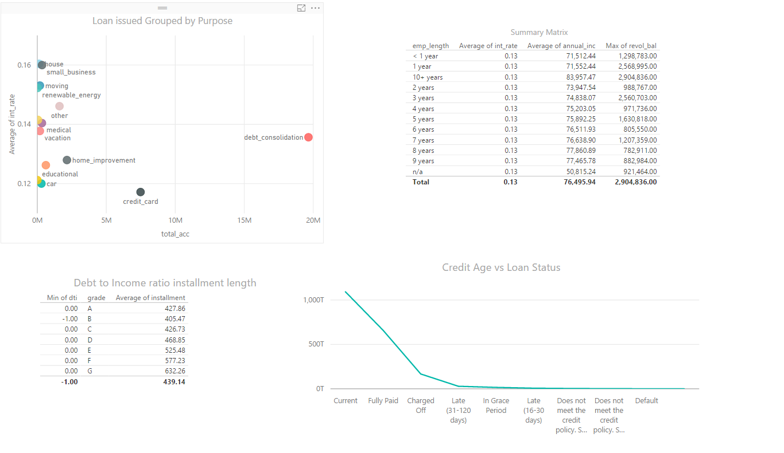

Time Hierarchy : over the years Loan approved

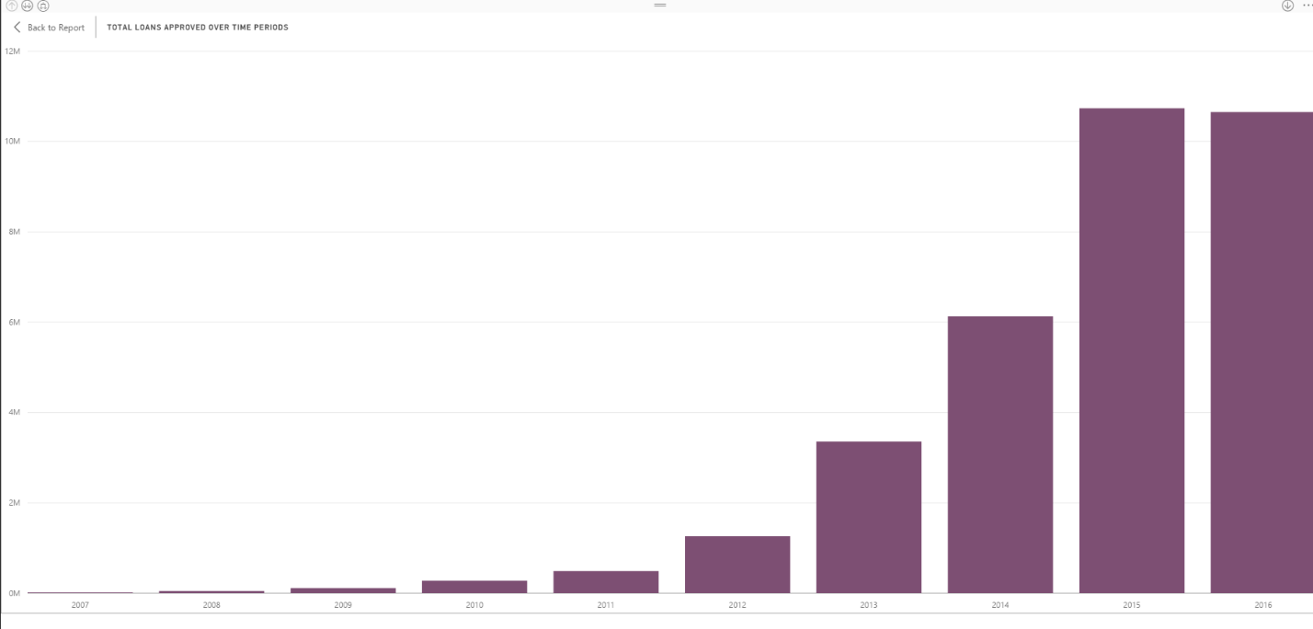

Time Hierarchy : Quarterly Loan approved

So it seems that the most loans are approved in quarter 4 then followed by quarter 3 then in 1st quarter

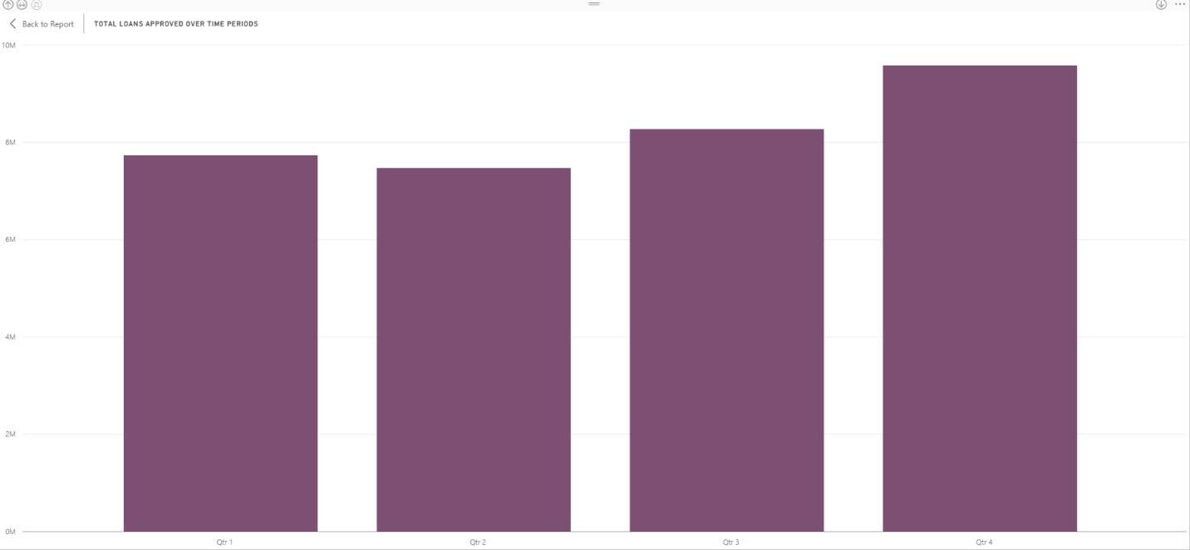

Time Hierarchy : monthwise Loan approved

Monthly loan approved which says October is the month with most approvals

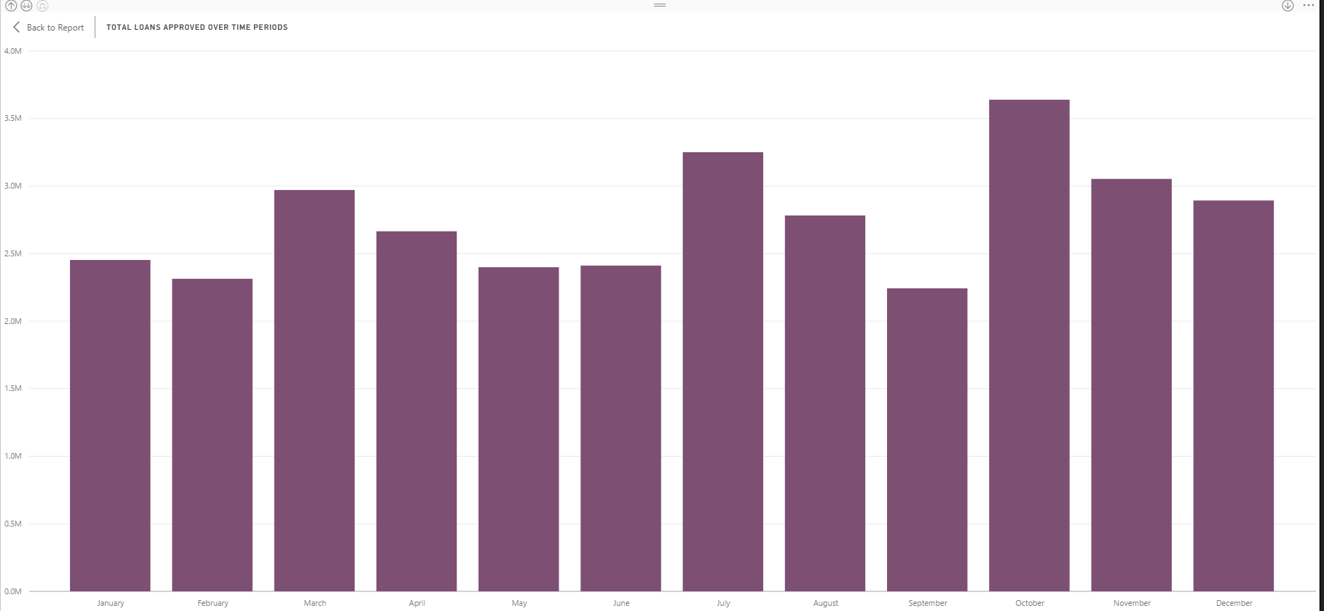

Donut -Loan Issued grouped by Grades

Show how loan varies with percentage. Those who are graded under C grade have been issued maximum loans followed by B grade then A

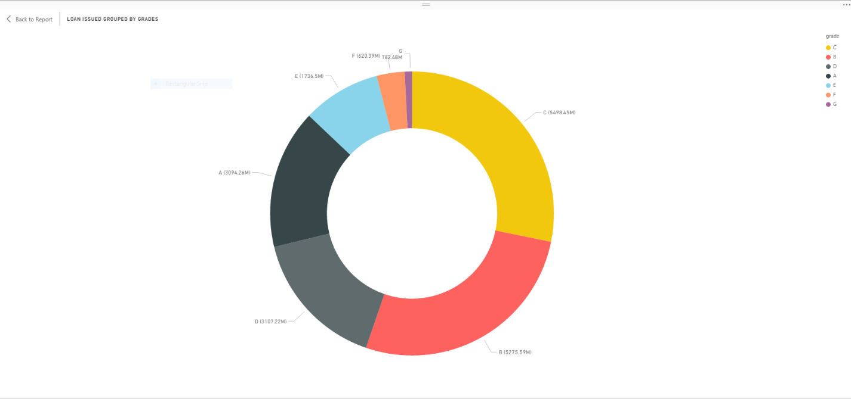

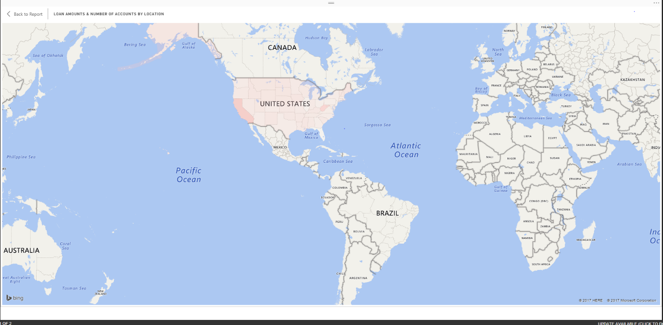

Donut -Loan Issues grouped by home ownership

Does home ownership have any relationship with Credit scores and Charge Off rates

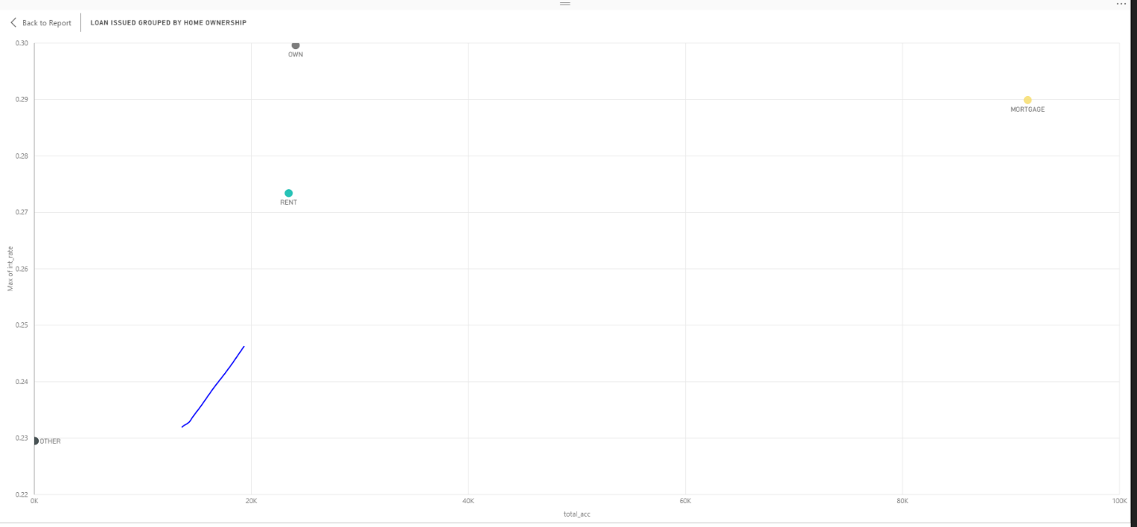

Loan Issued group by purpose

We want to see if there is any relation between credit scores, Charged rates and purpose. There is a strong correlation between charge off rates and if the purpose is either **educational** or **small business**. These loans tend to be a lot riskier.

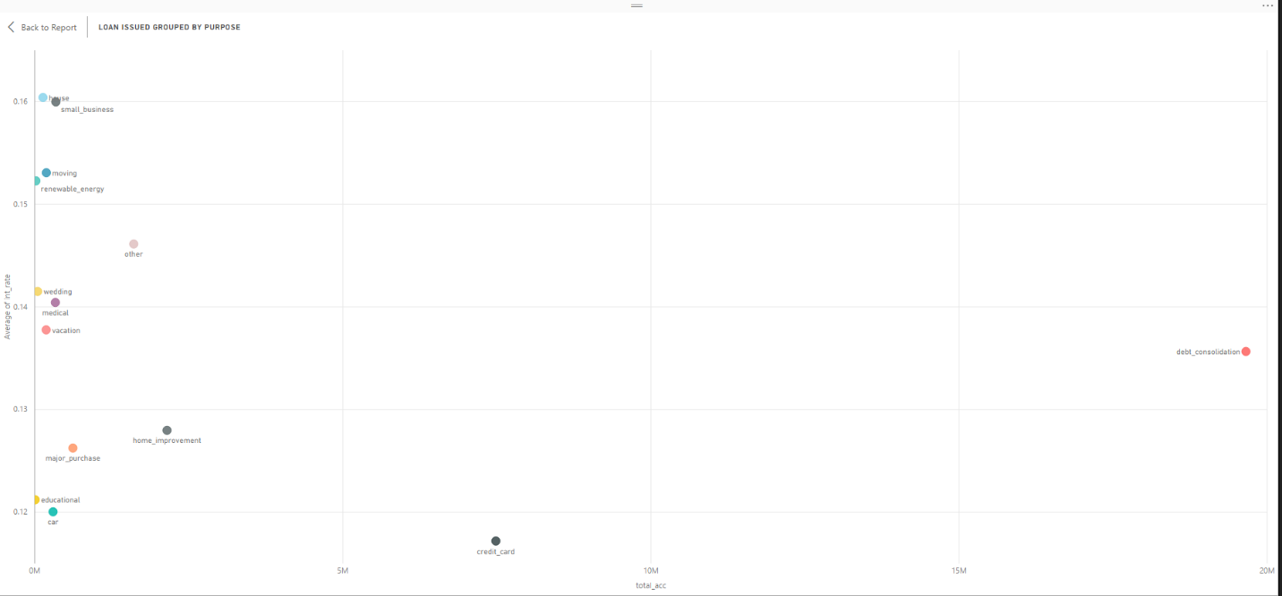

Summary Matrix summarising Employment length that & average of annual incomesare actually the features with the least obvious link to default rates:

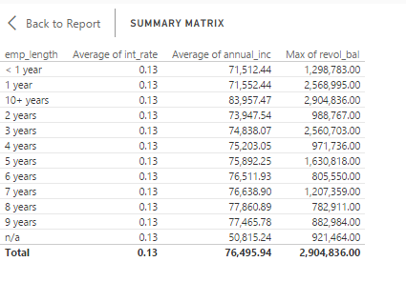

Debt to Income Ratio & Installment lengths

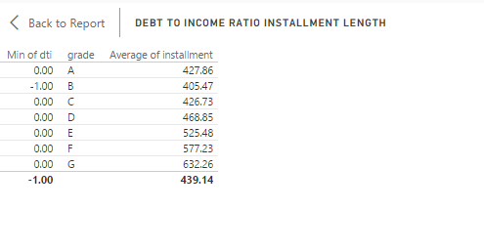

Credit Age vs Loan Status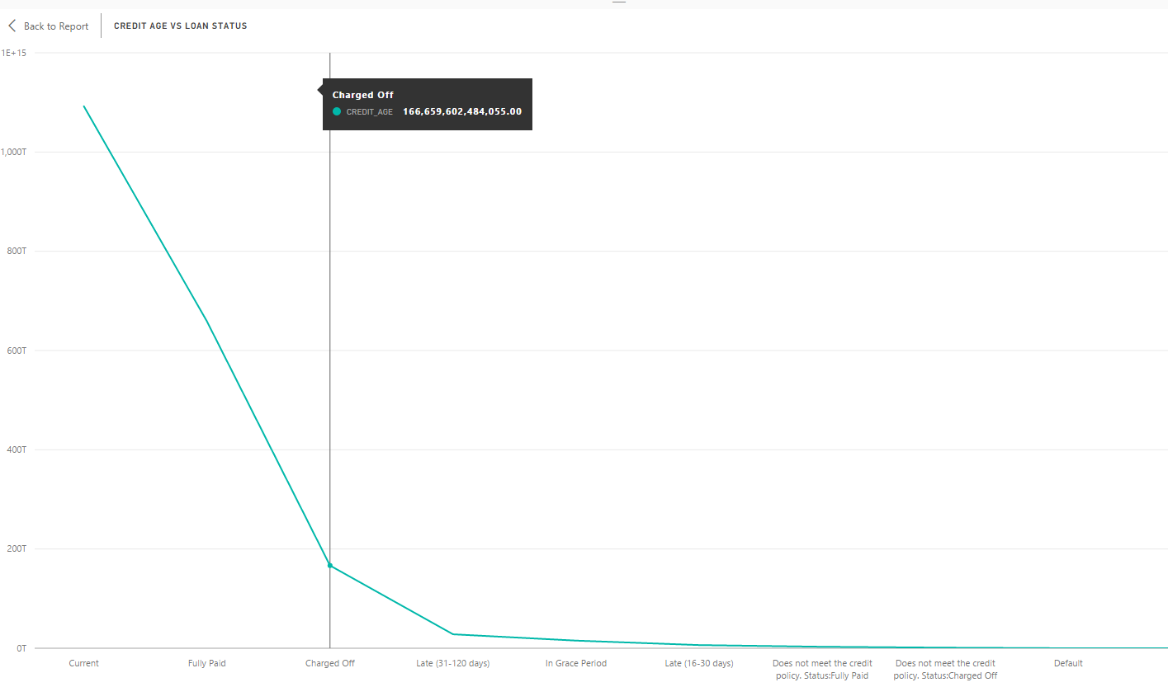

Credit age vs Loan Status



Rejected Data Dashboard

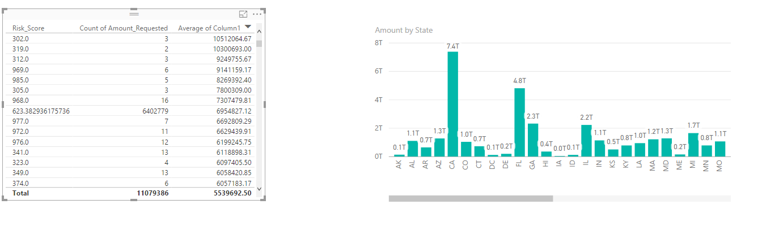

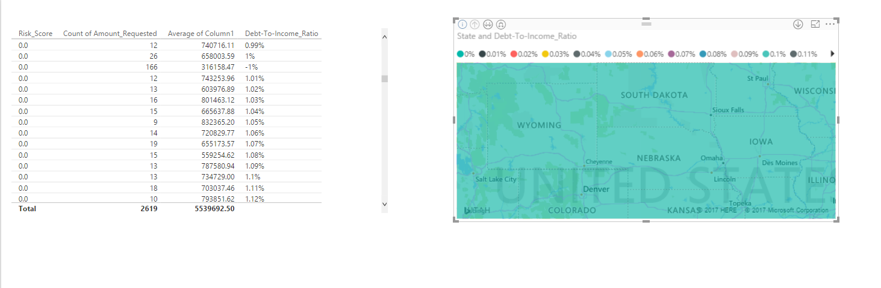

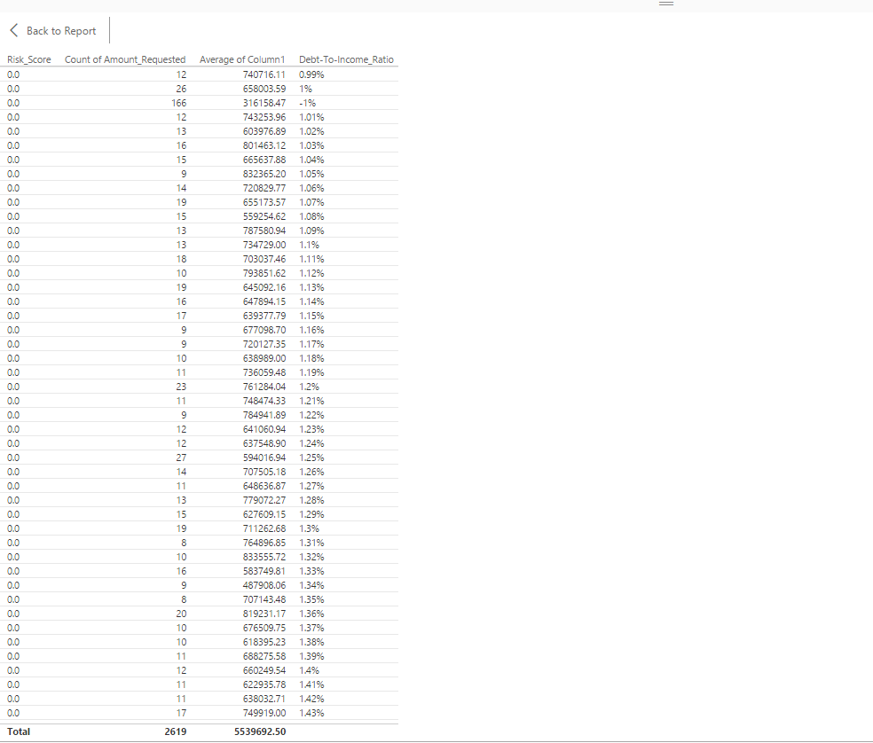

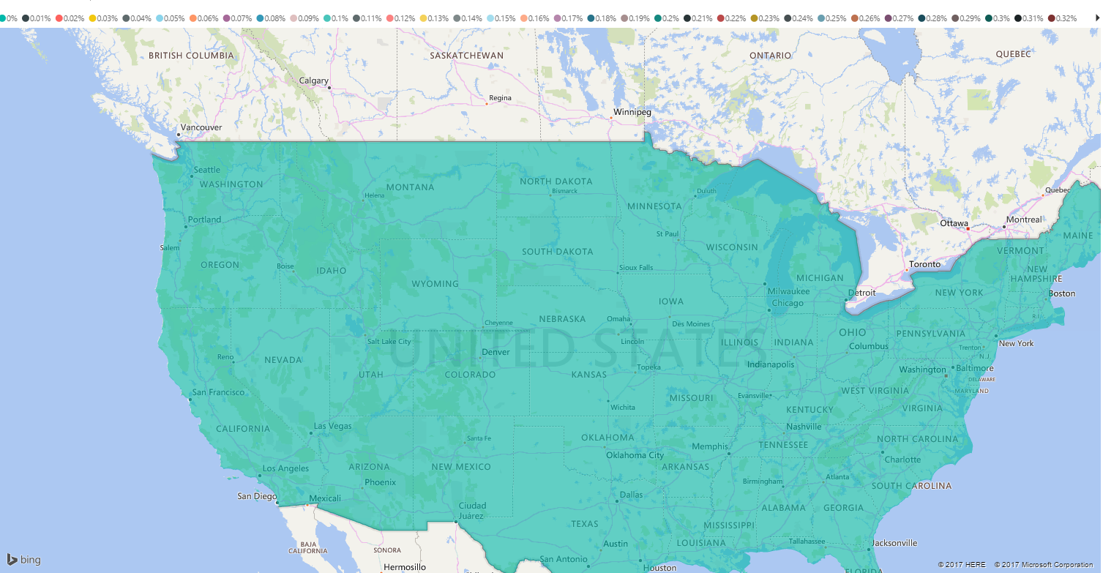

**Pipeline with Luigi (Accepted loan dataset):**

Pipelined tasks, data extraction, missing value handling and data exploration using luigi **for accepted loan data set**

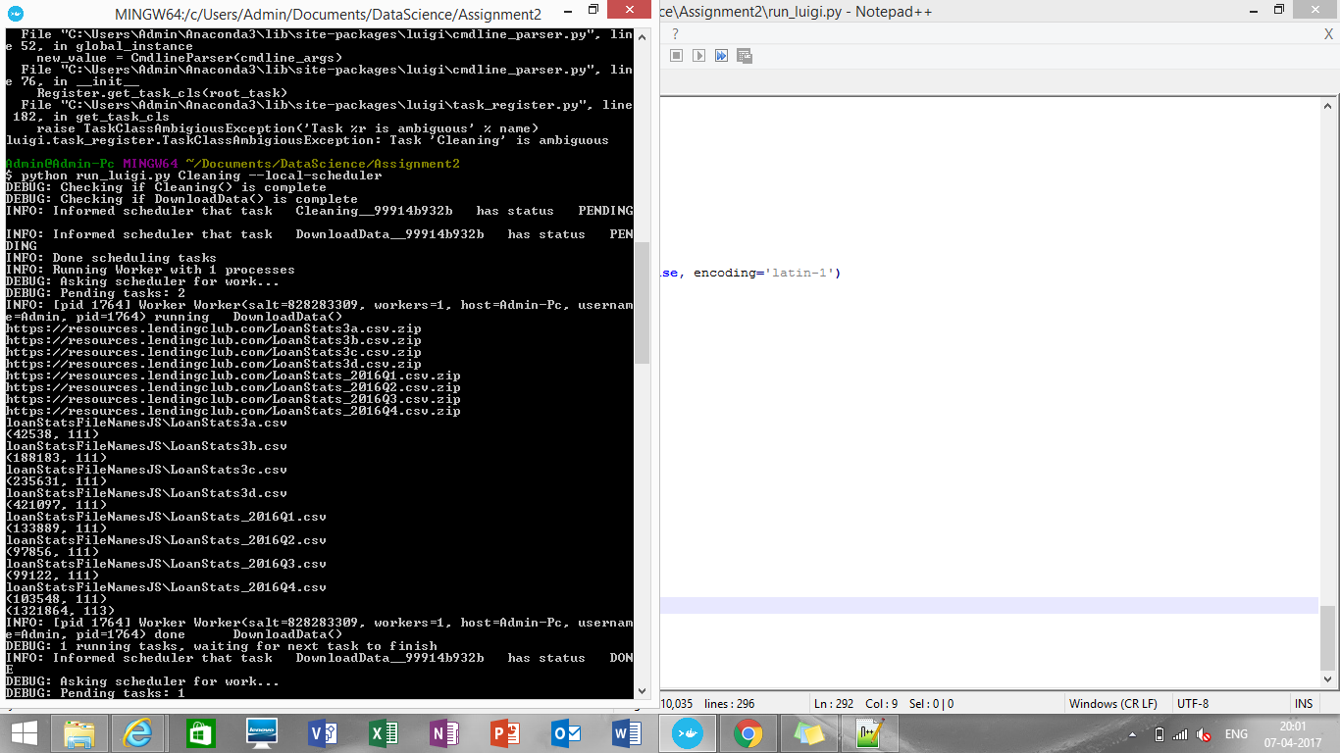

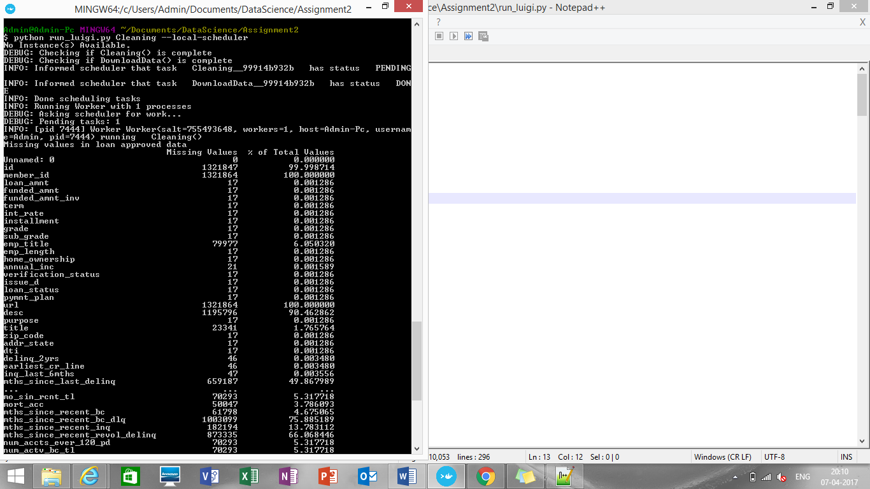

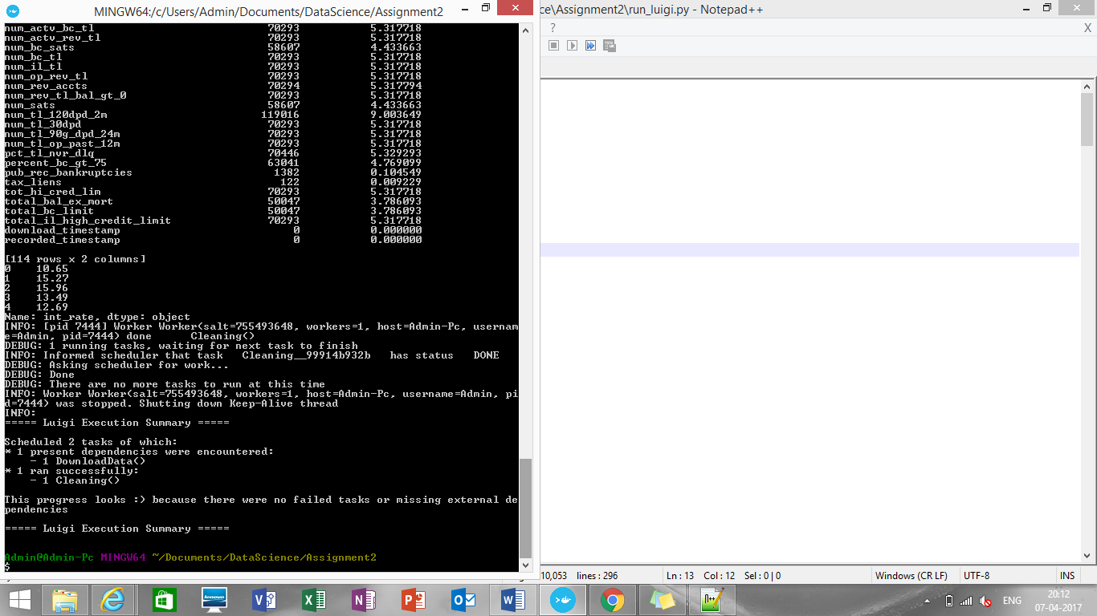

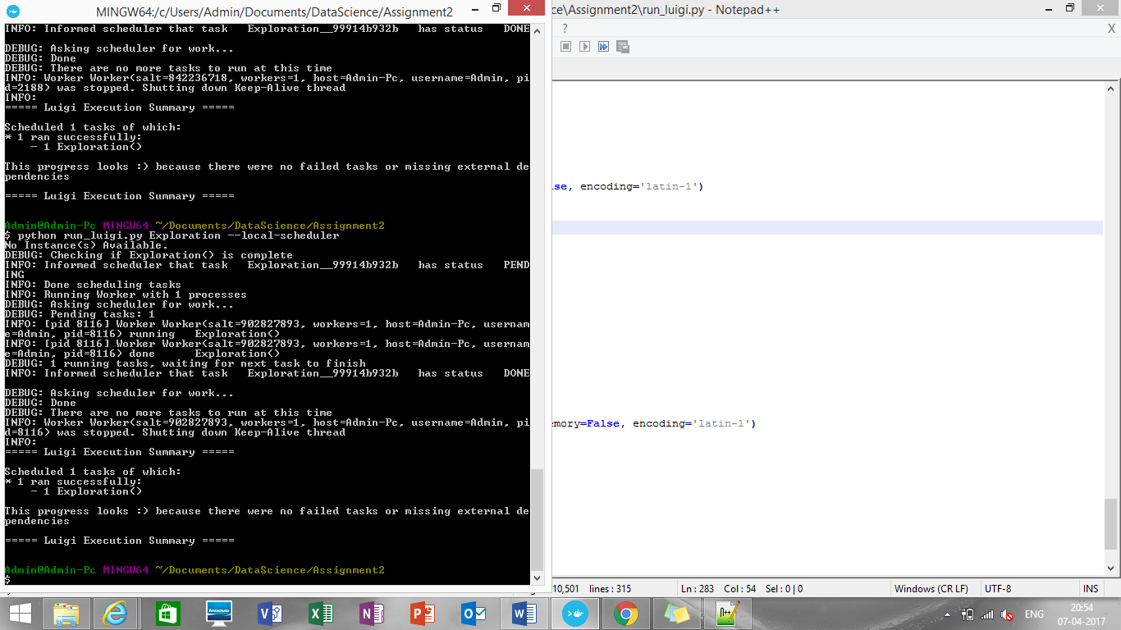

**Pipeline with Luigi (Declined loan dataset):**

Same steps are implemented for declined_run_luigi.py

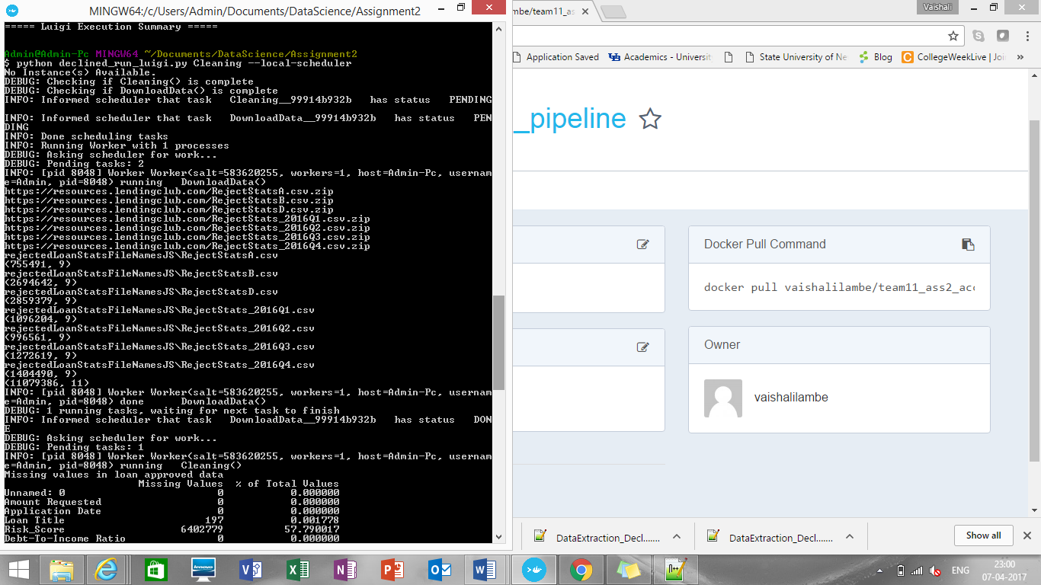

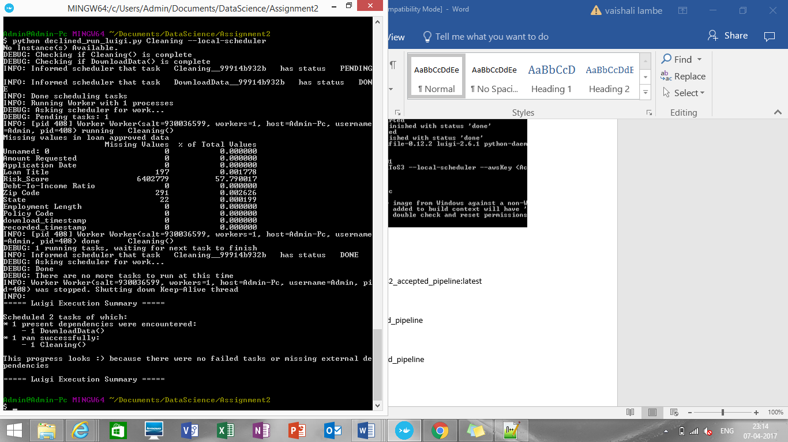

**Dockerization:**

**Building image for accepted loan data pipeline**

pushd C:/Users/Admin/Documents/DataScience/Assignment2/pipeline

docker build -t part1_accepted .

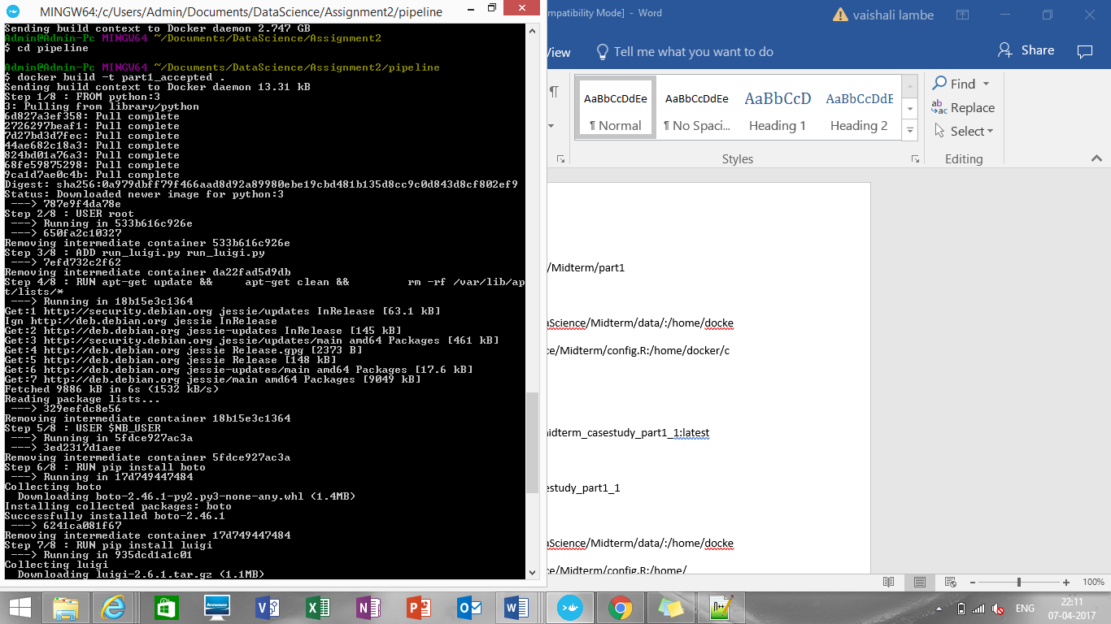

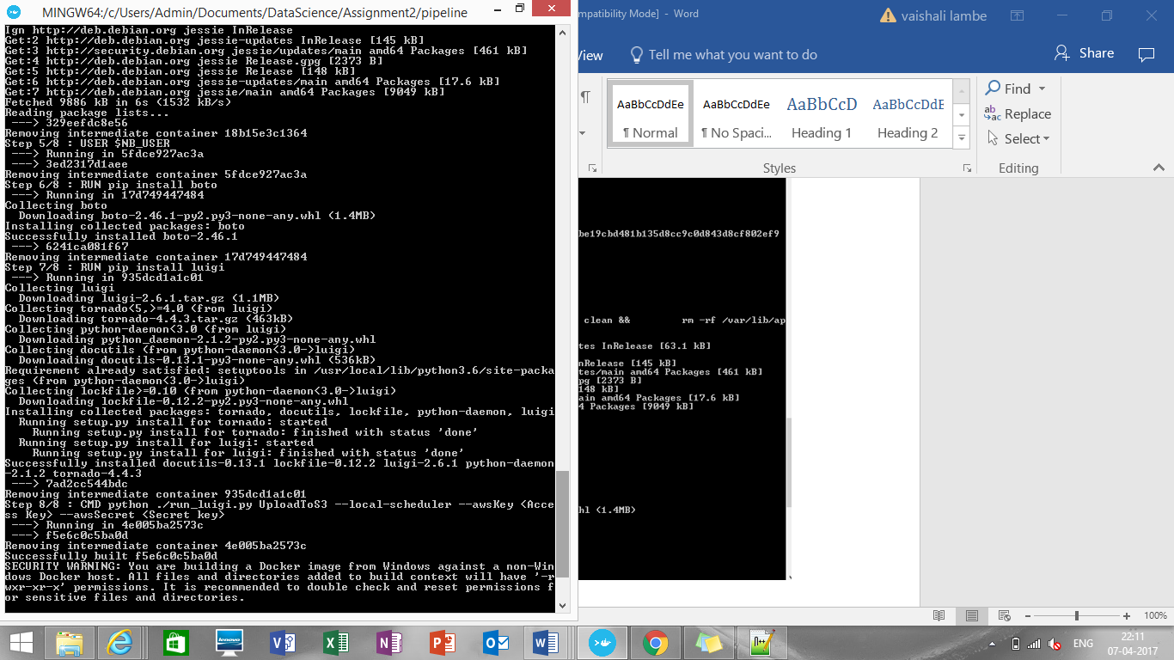

docker images

docker tag <IMAGE ID> [vaishalilambe](https://hub.docker.com/u/vaishalilambe/)/[team11_ass2_accepted_pipeline](https://hub.docker.com/r/vaishalilambe/team11_ass2_accepted_pipeline/):latest

docker login

docker push [vaishalilambe](https://hub.docker.com/u/vaishalilambe/)/[team11_ass2_accepted_pipeline](https://hub.docker.com/r/vaishalilambe/team11_ass2_accepted_pipeline/)

**To run the image**

$ docker run [vaishalilambe](https://hub.docker.com/u/vaishalilambe/)/[team11_ass2_accepted_pipeline](https://hub.docker.com/r/vaishalilambe/team11_ass2_accepted_pipeline/)

**Part2: Classification:**

**Script Name: logistic-regression.ipynb**

Logistic regression to predict whether a loan will be made or not.

**Approach:**

* Need to keep only the common columns: Amount Requested, Risk_Score, DTI, Employment Length
* Renamed these columns as 'loan_amnt', 'mean_fico', 'dti', 'emp_length' respectively in both accepted and rejected dataset
* Many of the rejected loans have no credit score (mean_fico) so replaced it with 0.0
* Splitted the accepted and rejected loan data: used first half for training and the second half for testing.
* Created testing and training dataframes
* Trained the models and got accuracy upto **93%**

predicted actual mapped

0 6.691107e-106 0 0

1 5.318409e-07 0 0

2 7.121803e-02 0 0

3 9.383251e-07 0 0

4 3.170916e-02 0 0

5 1.728196e-06 0 0

6 4.678660e-07 0 0

7 8.741394e-07 0 0

8 7.511548e-01 1 1

9 1.274070e-01 0 0

**Random Forest:**

**Script Name: RFNNandSVN.ipynb**

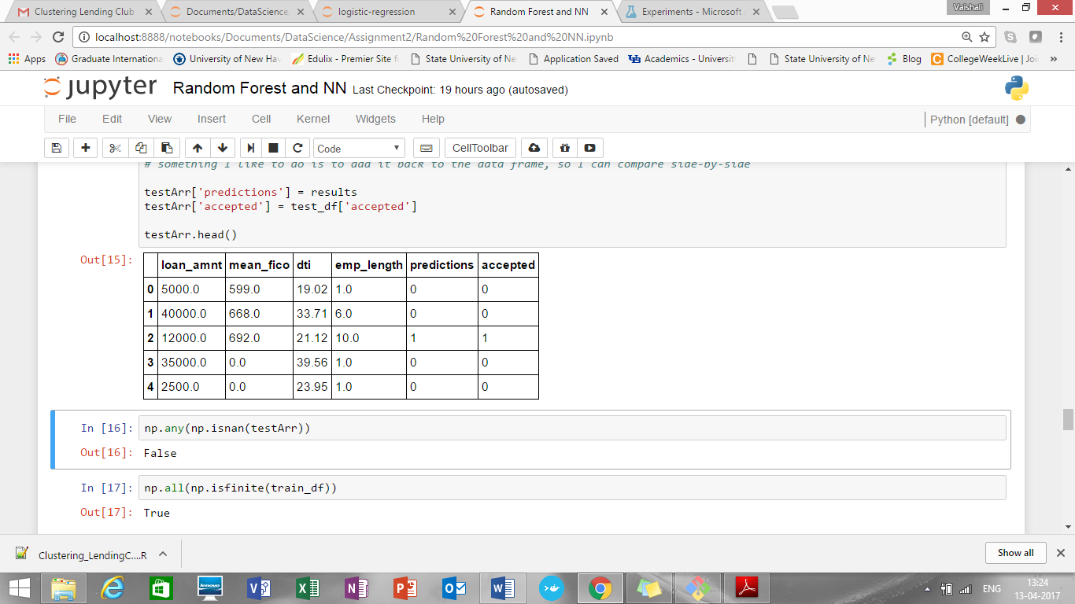

Accuracy of model is ~97%

**Neural Network:**

**Script Name: RFNNandSVN.ipynb**

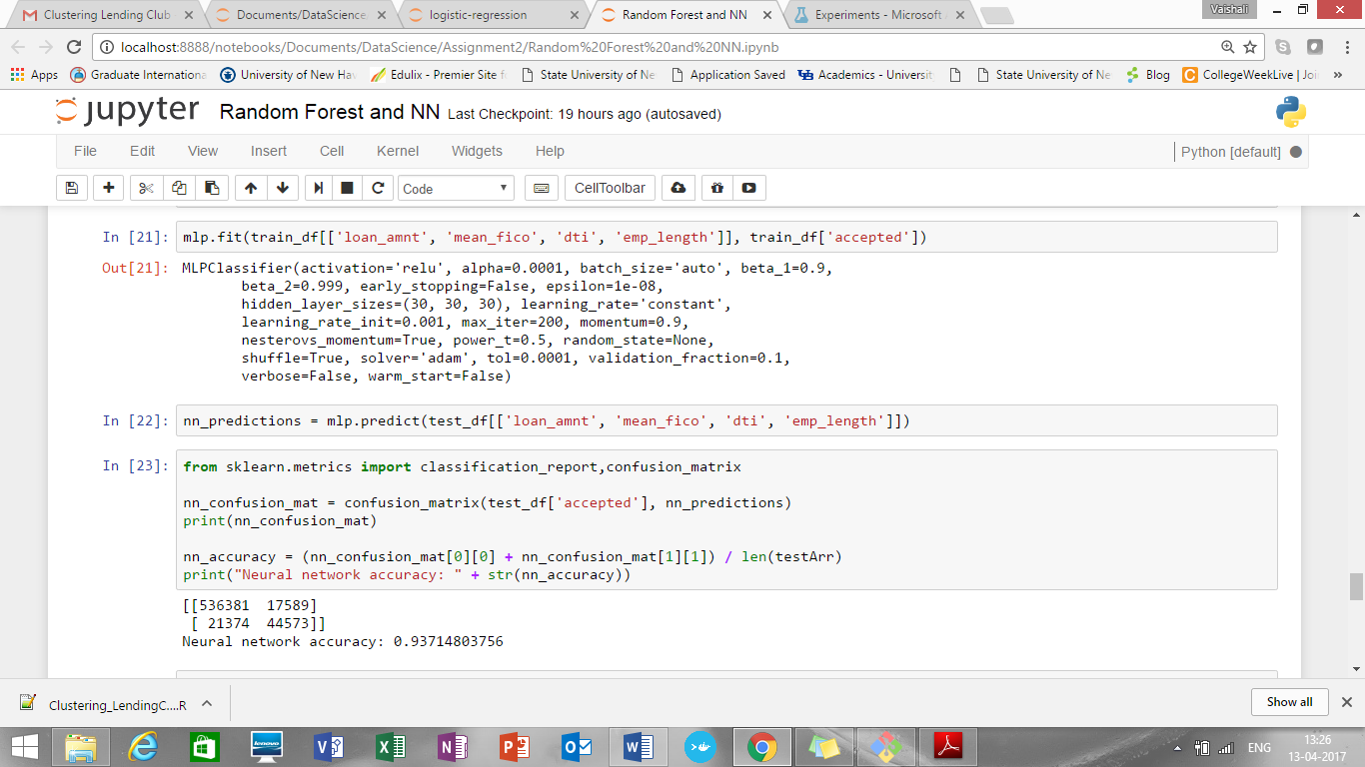

Accuracy of model is ~94%

**SVN algorithm:**

**Script Name: RFNNandSVN.ipynb**

[[553698 272]

[ 64579 1368]]

Support vector machine accuracy: 0.895387608341

Accuracy is **~ 89%**

**Rest API for Microsoft Azure ML Studio:**

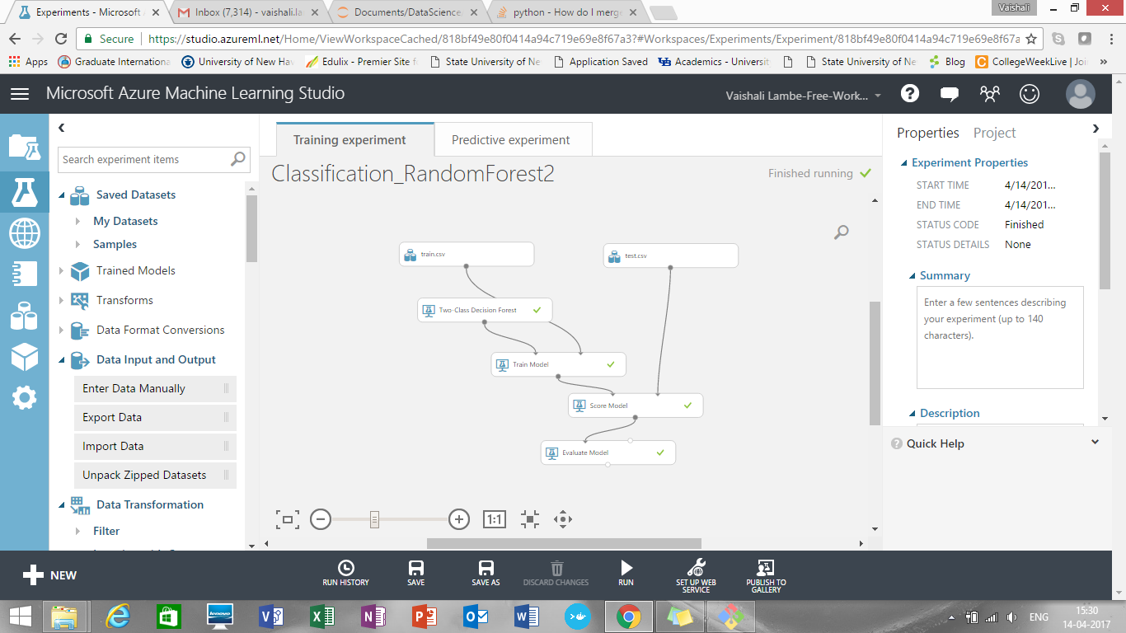

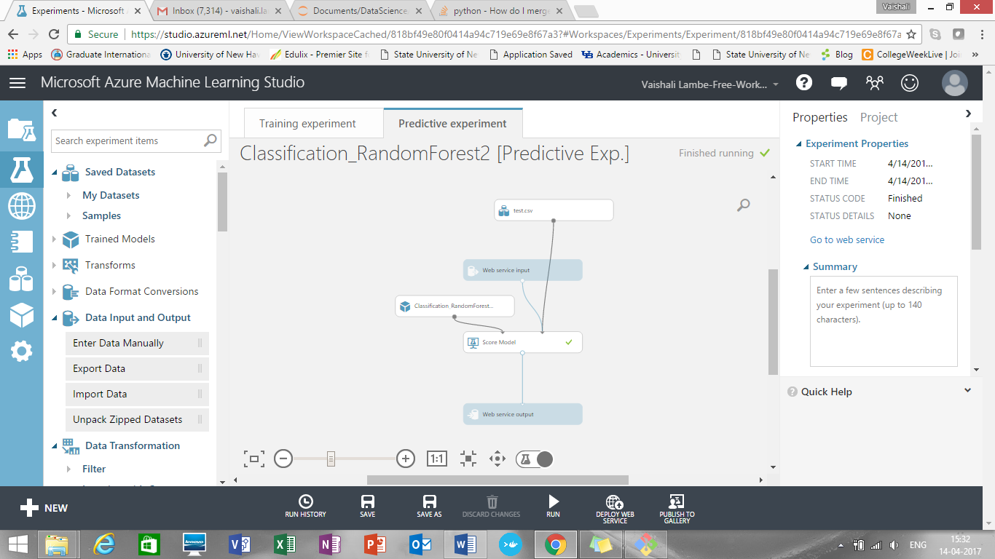

**Results after deploying the web service:**

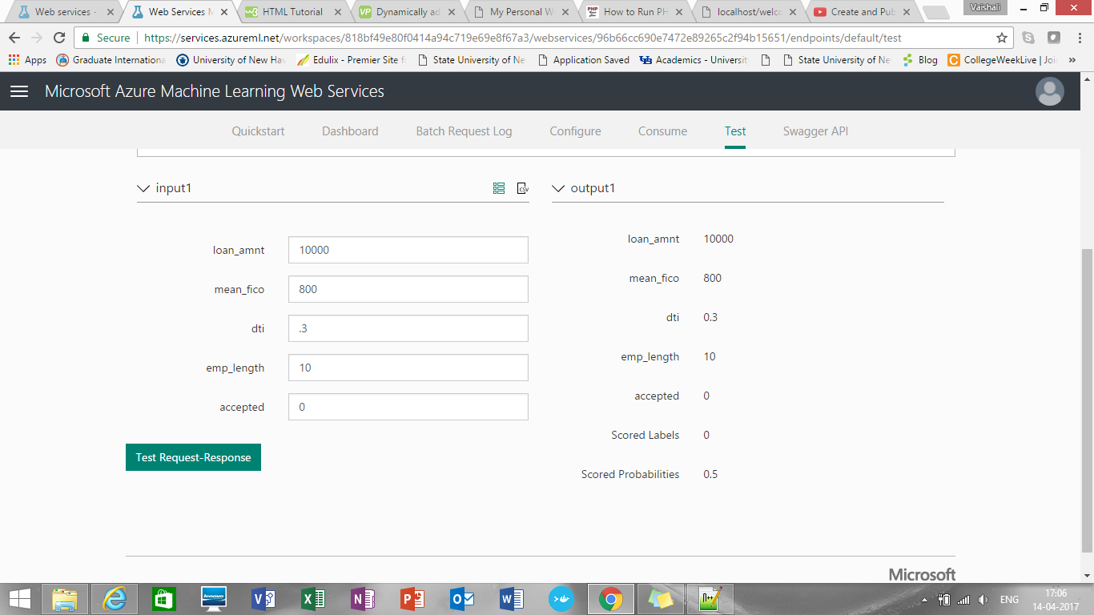

'Classification_RandomForest2 [Predictive Exp.]' test returned ["10000","200","0.1","1","0","0","0"]...

* Result: {"Results":{"output1":{"type":"table","value":{"ColumnNames":["loan_amnt","mean_fico","dti","emp_length","accepted","Scored Labels","Scored Probabilities"],"ColumnTypes":["Double","Double","Double","Double","Int32","Int32","Double"],"Values":[["10000","200","0.1","1","0","0","0"]]}}}}

**UI Part:**

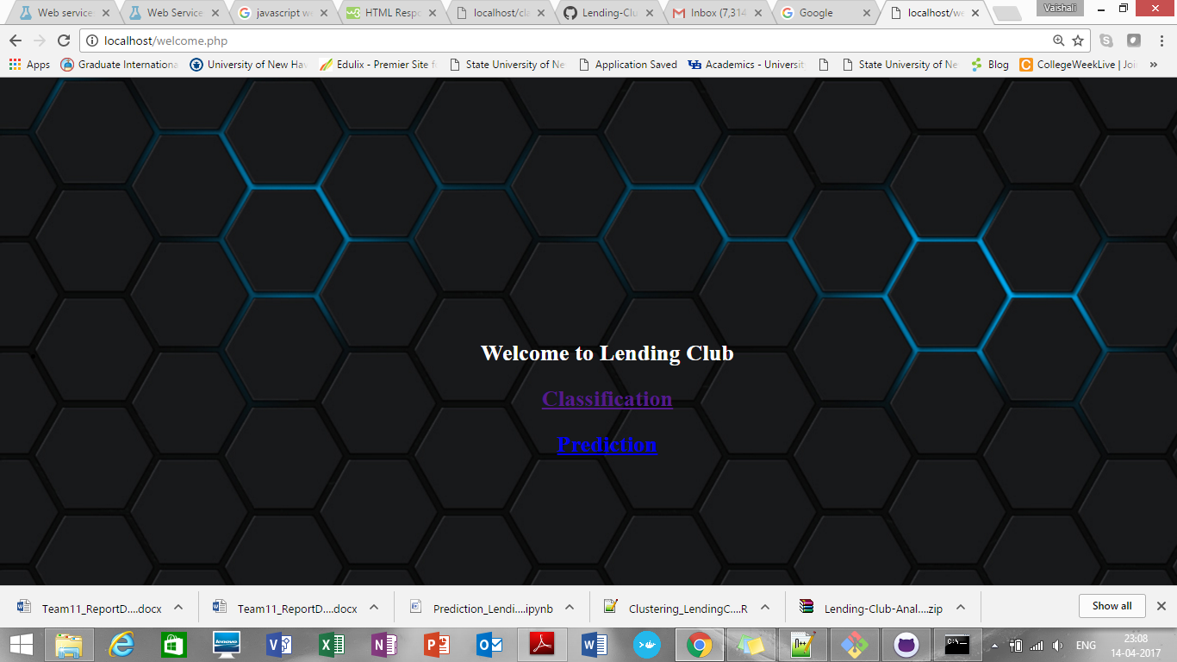

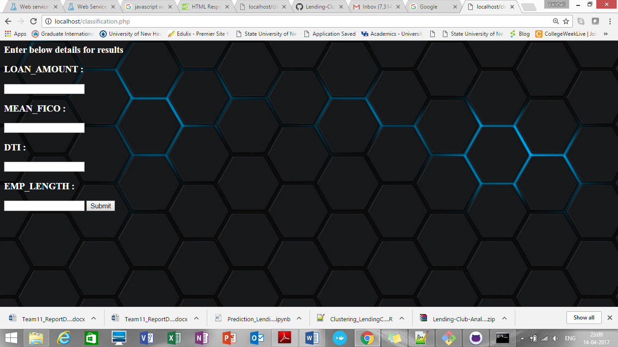

**Clustering:**

**Approach:**

**k-means clustering**

**Script Name: k-means-clustering-exploration.ipynb**

* Attempt to predict the interest rate charged to a group/cluster of loans.
* Start by examining the clustering in the data.
* Only need accepted loans for this.

**Outlier removal:** There's a row with an income of 4.3m that is badly skewing the results, so remove it for now.

So only consider records with annual income below 1M now to get proper clusters

Otherwise the clusters won’t be segmented.

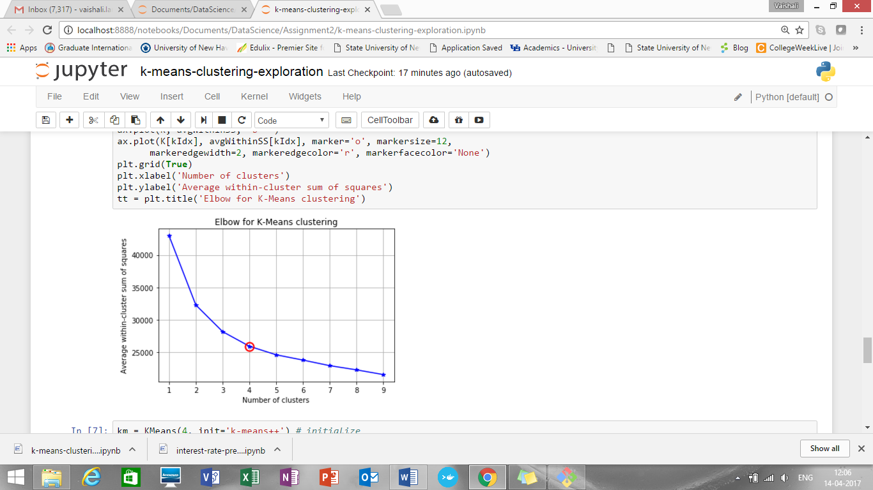

As per above graph, after 4 clusters there is no much difference in the segmentation. So we will take number of clusters for it as 4.

1. Loan amount Vs Annual Income

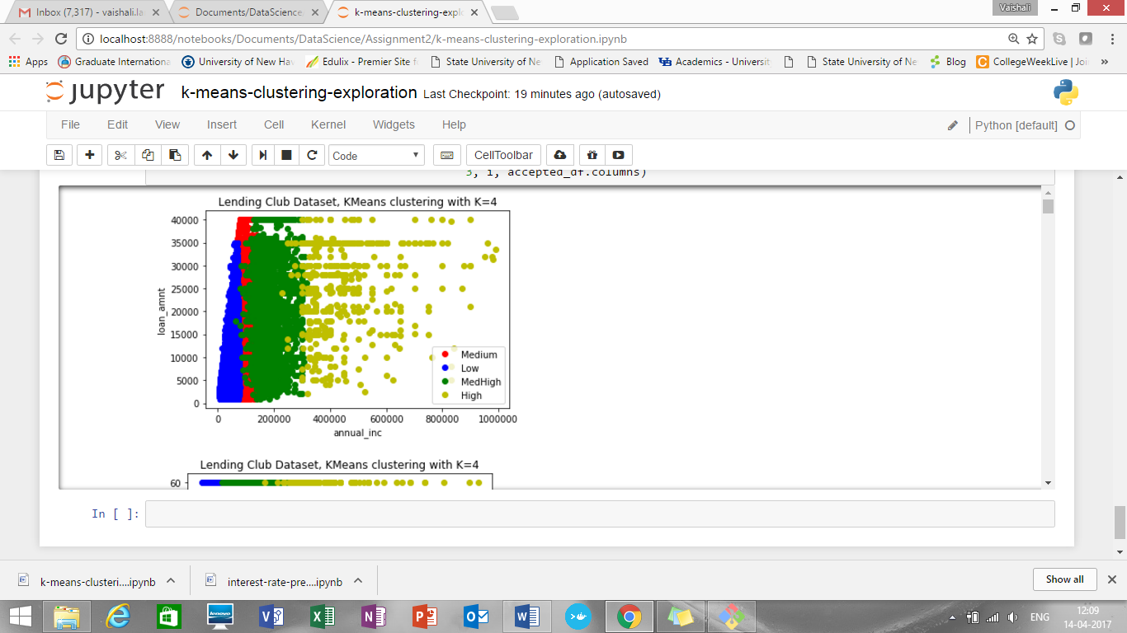

1. Term Vs Annual Income

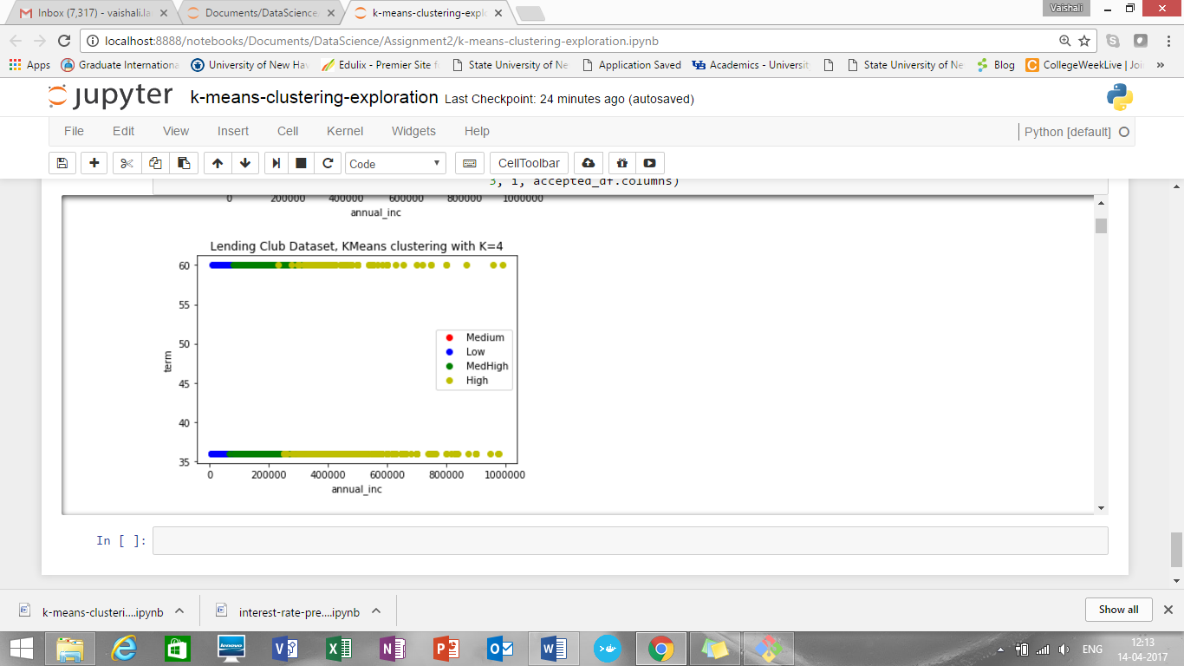

1. Employment length Vs annual income

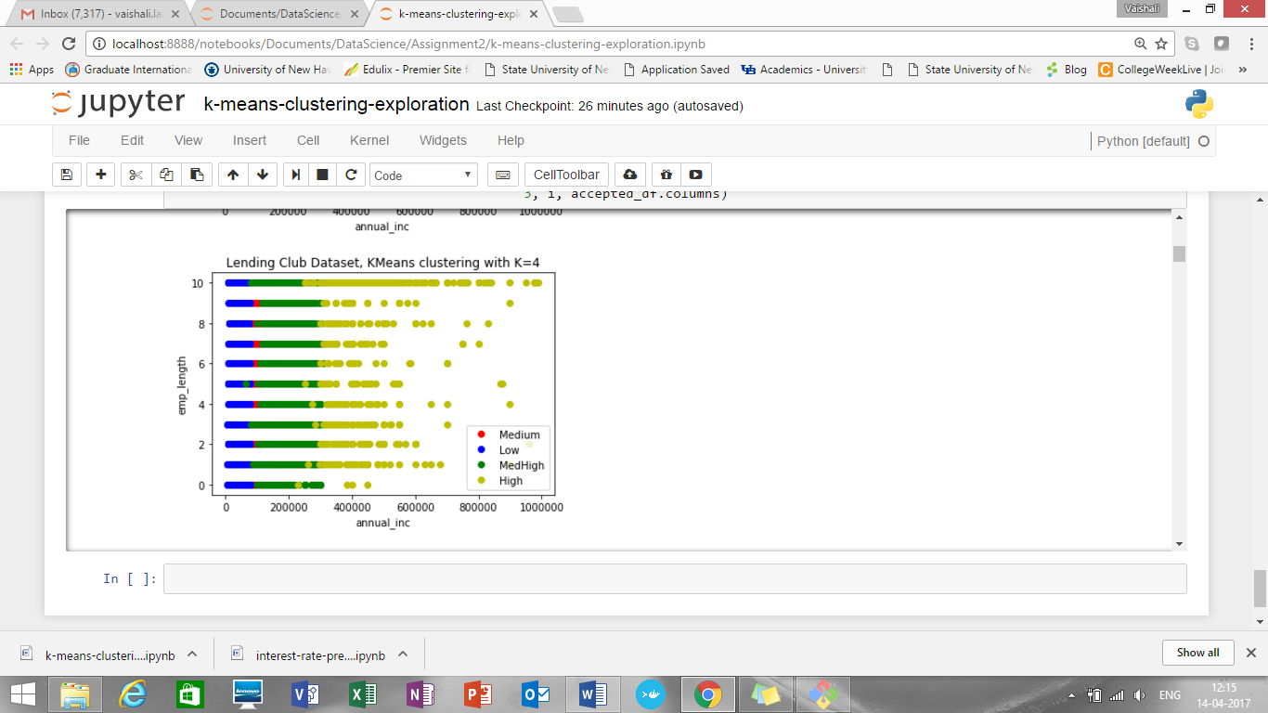

1. DTI Vs. annual income

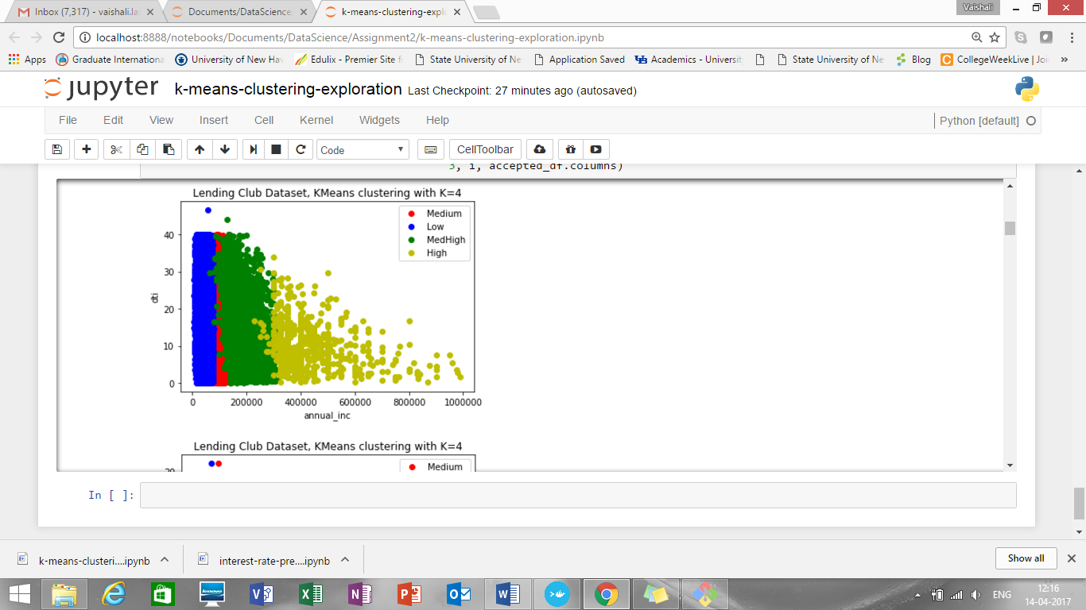

**Prediction:**

**Predict the interest rate:**

1. **Linear regression:**

**Script Name: interest-rate-prediction-linear-regression.ipynb**

* uses all the accepted loans, i.e. no segmenting/clustering.

**Coefficients:**

[[ 0.46728469 1.70537976 -0.02228413 -0.19746662 0.52047471 0.08683277

-0.19135679 0.83562216 -0.09196297 -0.05546849 -0.24220846 0.3096084

-0.70188735 -0.00500134 0.81432747 -0.08992683 -0.40736942 -0.02532263

0.01828071 0.01658771 0.03755726 -1.20824699 -0.21832669 0.00521397

0.02148635 -0.02096725 0.39450338]]

**Mean squared error: 11.62**

**Root mean squared error: 3.41**

Variance score: 0.45

**Part2: Prediction**

Script Name: Prediction_LendingClub.ipynb

Approach:

* Need to keep only the common columns: Amount Requested, Risk_Score, DTI, Employment Length
* Splitted the accepted and rejected loan data: used first half for training and the second half for testing
* Created testing and training dataframes
* Clusters are formed based on following features:

**Cluster1:**

Loan_amnt between 1000 and 12000

emp_length between 0-3

Annual income between 10,000-64961

**Cluster 2:**

Loan_amnt between 12001 and 16944

emp_length between 4-7

Annual income between 64962-100000

**Cluster 3:**

Loan_amnt between 16944 and 35000

emp_length between 8-10

Annual income between 100001-400000

**Visualizations using tsne:**

**Summary metrics:**

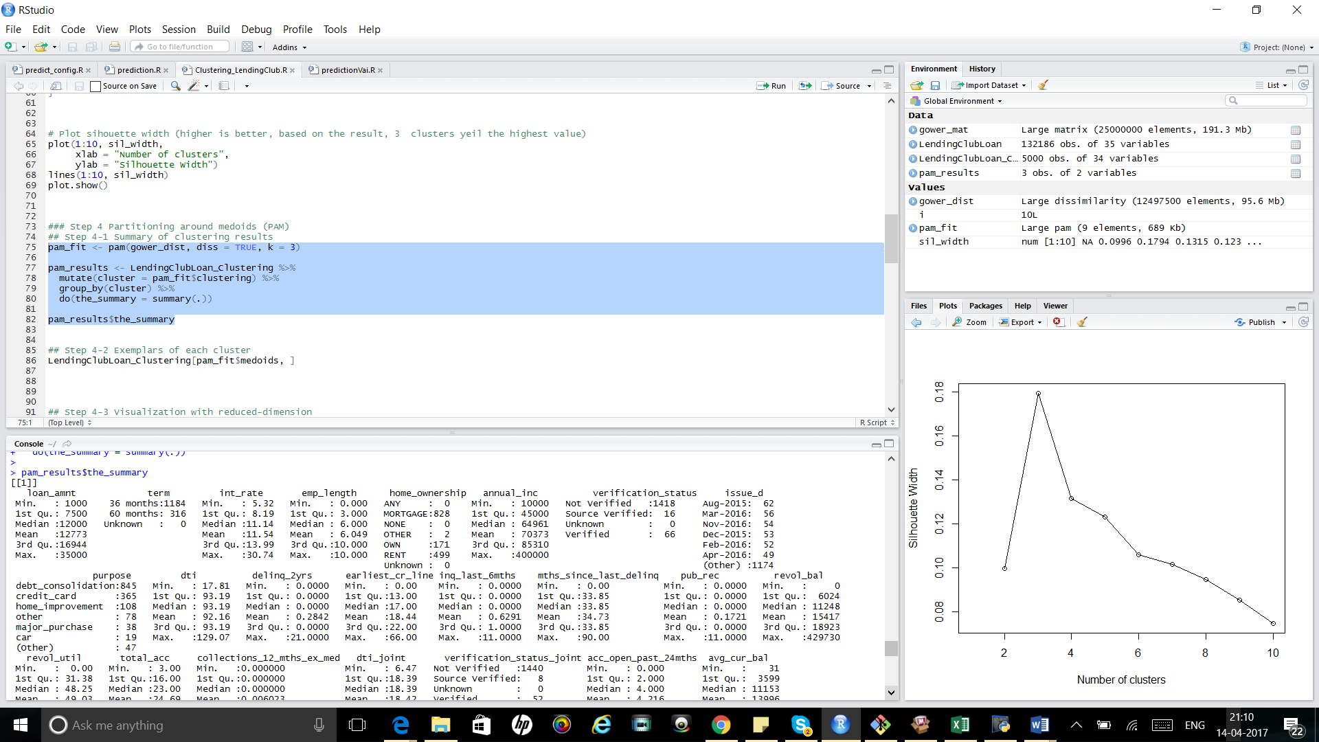

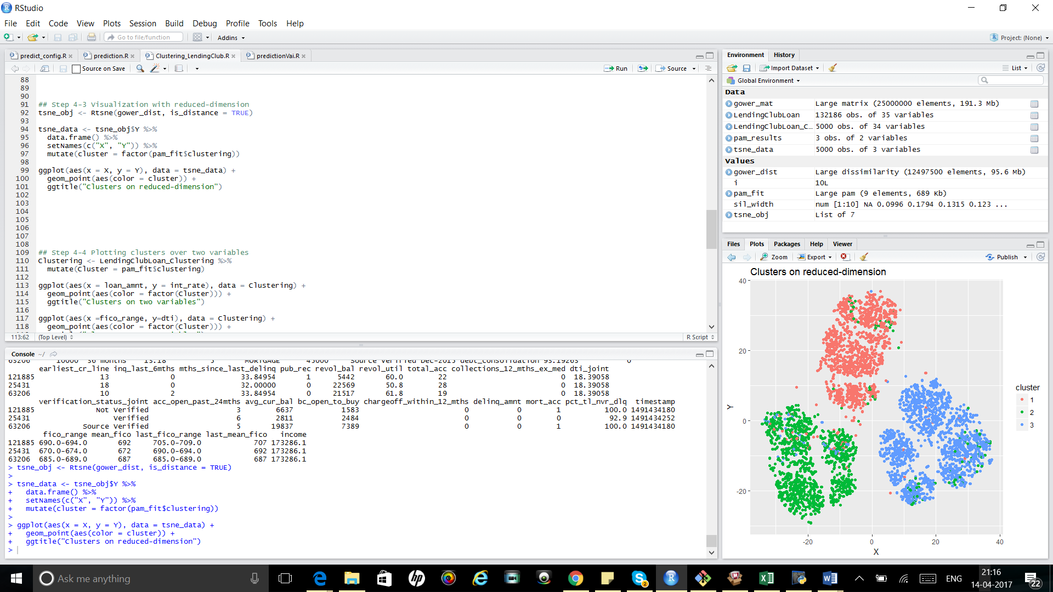

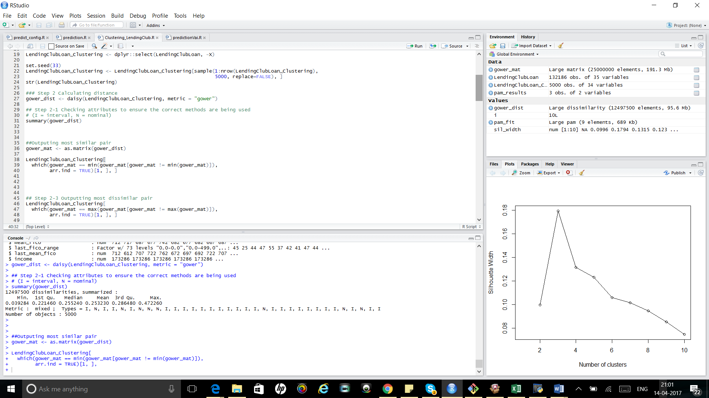

1. Random Forest

Script Name: Prediction_LendingClub.ipynb

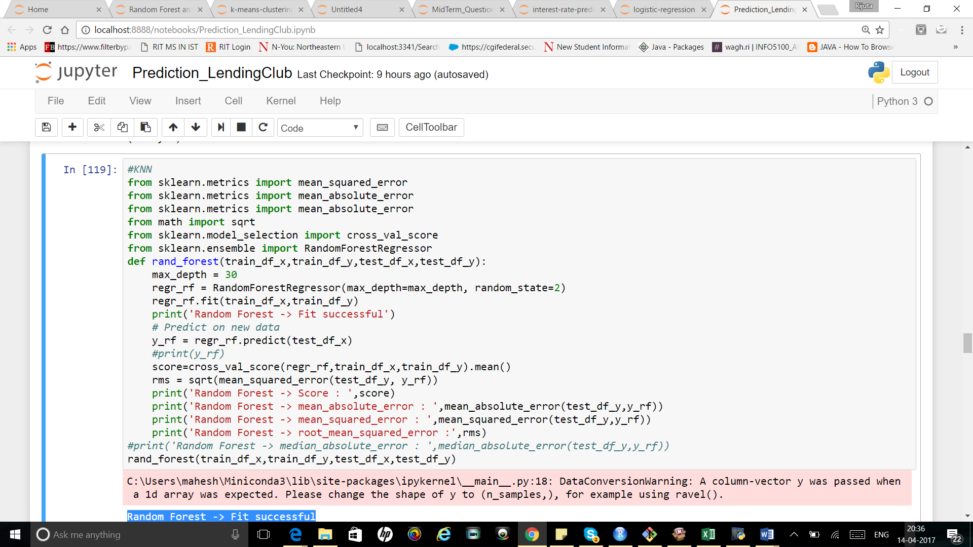

Results:

Random Forest -> Fit successful

Random Forest -> Score : 0.078144474522

Random Forest -> mean_absolute_error : 3.16908932903

Random Forest -> mean_squared_error : 16.6376472368

RMSE 4.07892721641253

1. KNN

Script Name: Prediction_LendingClub.ipynb

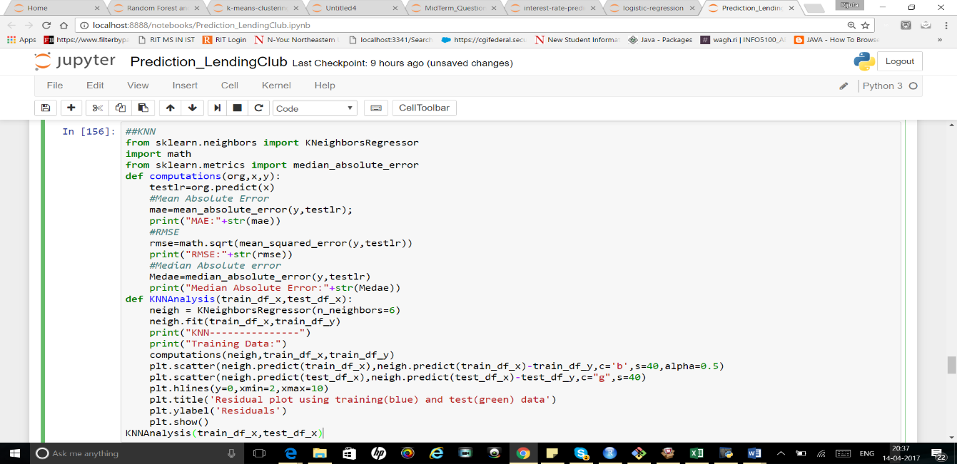

Results:

MAE:2.85108312937

RMSE:3.6477975530534903

Median Absolute Error:2.35833333333

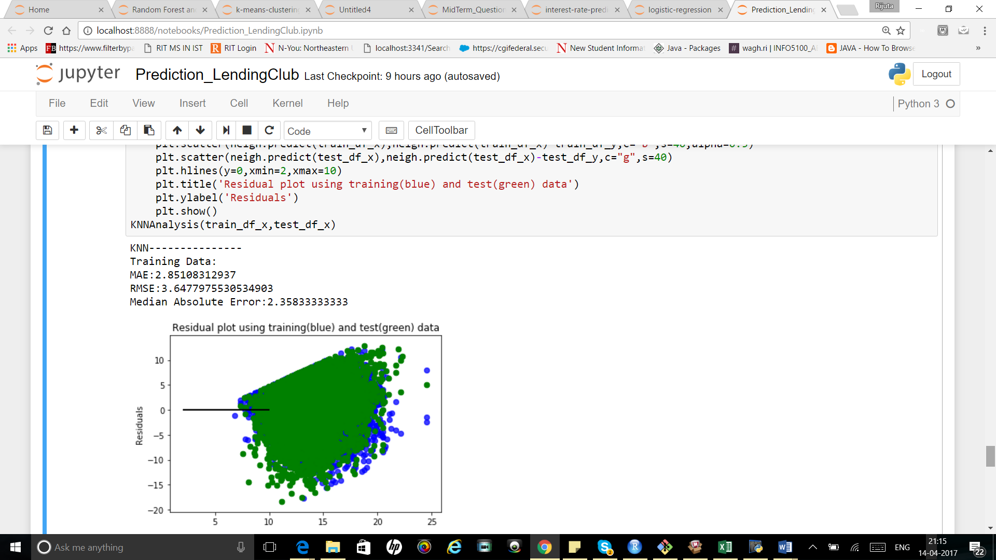

**Publishing an API in Domino:**

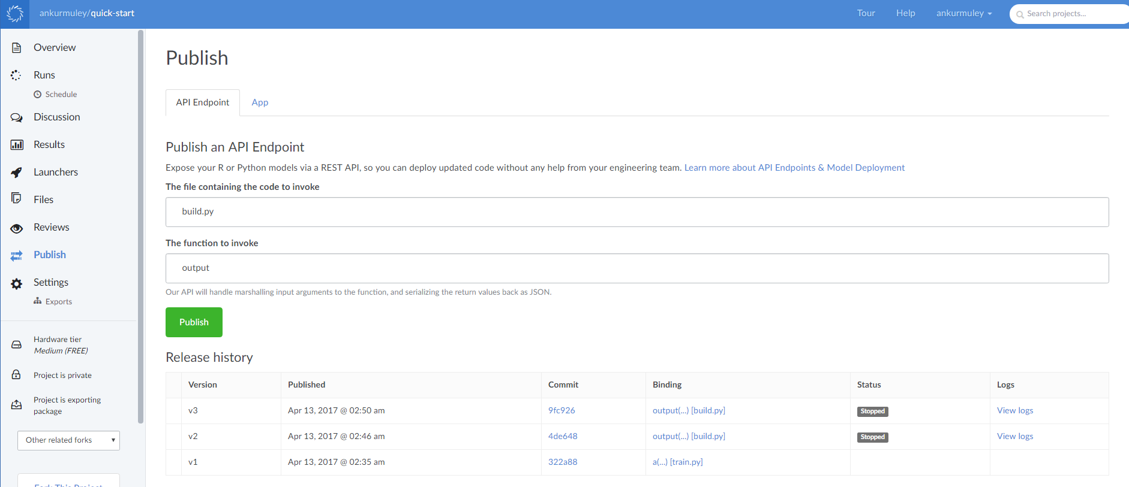

**Contribution Pie Chart:**

Tasks done Vaishali: Accepted loan data, extraction, missing data handling, exploration, Dockerization, pipeline luigi (both accepted and decline data), report preparation, docker commands, Logistic regression for classification, SVN algorithm for classification, K means clustering, Linear regression for prediction, Microsoft Azure Rest API, UI in PHP, github upload

Tasks done Rijuta: Rejected loan data, extraction, missing data handling, exploration, report documentation, Random Forest for classification, Neural Network for classification

Tasks done Ankur: PoweBI analysis for accepted and rejected data, report documentation for powerBI , Domino Rest API